
I’VE GOT A PROJECT
NOW WHAT DO I DO?

January 2011

By

Valerie Horton, PE

LaDOTD Road Design

Enhancement Unit

FOREWORD

Congratulations on having a successful application. The personnel of the Enhancement Unit are looking forward to assisting you make your vision a reality. We are committed to providing friendly, helpful service to our Sponsors. It is our goal for each Sponsor to be provided with the information they need in order to bring their project to construction in a timely manner.
The purpose of this manual is to provide a guide toward developing your project within the LaDOTD framework. Since most projects fall under the 95/5-match system, this manual is geared for those projects. If your project is an 80/20 match, please contact the DOTD Enhancement Coordinator assigned to your project. Unusual projects do occur within the Transportation Enhancement (TE) Program, so please do not hesitate to call if questions do come up that this guide does not answer.
The intention is to update this manual on a yearly basis so the latest information will be available to our partners. Upon reading this manual, if you have any suggestions for improving it, please let us know what they are.
Sponsors should be aware that this is not a grant program, but a cost-reimbursable, pay-as-you-go program. This means that the Sponsor pays the contractor first; then LaDOTD will reimburse the Sponsor in accordance with the program guidelines. The development of your enhancement project will be a joint effort between LaDOTD, FHWA and you. You will be assigned your own LaDOTD DOTD Enhancement Coordinator to help guide your project through to completion. To that end, again please feel free to call on the Enhancement Unit if we may be of assistance in anyway.
Also Sponsors should note that this manual is actually a part of the City/Sponsor Agreement; therefore, we urge you to familiarize yourself with it.
For more information concerning the background of the TE Program and how to apply for the program, please refer to the Transportation Enhancement Information Guide, latest edition posted at www.dotd.louisiana.gov.

Valerie A. Horton, P.E.
Enhancement Program Manager

TABLE OF CONTENTS

Foreword 1

Table of Contents 2
When Do I Get The Check? 4
What’s My Funding? 4
How Soon Will My Project Be Under Construction? 4
What’s My Next Step? 5
When May The Design Start? 5
Should I Attend The Kickoff Workshop? 6
Why Do I Need To Have The Project Scoped? 6
What’s Environmental Clearance? 6
What Permits Do I Need? 7
Who Prepares The Agreement And When? 7
What About The Right Of Way? 8
What Is the Project Deliverables Process? 8
What Design Standards Should Be Used? 9
What About The Plan Format? 10
What Common Elements Are Looked For? 10
What Should The Specifications Look Like? 11
What Are The Basic Guidelines For Each Project Type? 12
Bicycle And Pedestrian Facilities Projects 12
Architectural Projects 13
Landscaping Projects 13
What If I Have Utility Relocations? 14
What’s A Plan-In-Hand? 14
What Is Needed For Advanced Check Prints (ACP’s)? 15
What Is Needed At Final Submission? 15
How Much Money Do I Need On Hand? 16
What Type Of Match Can Be Used? 16
Real Property Match 16
Cash Match Sources 16
Can The Project Scope Be Changed? 16
What About Press Releases? 17
What’s The Last Step Before Letting? 17
What If An Addendum Is Needed? 17
What Happens Now? 18
Construction Overview 18
Let’s Get Specific About Construction 19
“Where’s the Money, Honey?” 22
Appendix 24
Acknowledgements 25
Website Link To Manuals 26
List Of Terms 27
Sponsor Checklist 29
Consultant Checklist Overview 30
Sample Environmental Clearance Packet 31
Sample Agreement 43
Guidelines for Sponsor’s Engineer Acting as “Project Engineer” 54
Project Engineer Checklist 55
Sample Change Order 57
Sample Preliminary Estimate Worksheet 58
Sample Material Memo 59
Example Sampling Plan 60
Metropolitan Planning Organization (MPO) Map 68
MPO Directors 69
Contacts 71
LaDOTD Districts Map 72
District Administrators 73
District Real Estate Officers 74
WHEN DO I GET MY CHECK?

Remember this is a cost reimbursable, pay-as-you-go program. It is not a grant. The money is not paid in a lump sum check to the Sponsor. The money is not actually deposited into a spending account for your project until the final bid documents have been approved (authorized) by the FHWA. The letting date is not set until final plan documents have been received and approved by your coordinator. In no case will money be set up until the project has been authorized by the FHWA. The “rule of thumb” is: Do not start with any work for which you expect to be reimbursed until you are notified in writing from LaDOTD to proceed. If in doubt, call your DOTD Enhancement Coordinator.

WHAT’S MY FUNDING?

The maximum federal funding for the project is set by the amount requested in the application to the program. Funding caps for your project are posted on the LaDOTD website at www.dotd.louisiana.gov along with the announcement of successful projects taken into the program.

Additional funding for project costs in excess of the maximum Federal funds awarded will not be provided. The Sponsor will be responsible for any cost in excess of the maximum Federal funds. Sponsors should carefully control increases and overruns as they may jeopardize completion of the entire project. If the Sponsor decides not to complete a project, the Sponsor shall reimburse all federal expenditures, if any, to the LaDOTD.

If the Sponsor elects, additional funding may be requested for the project during the next project selection cycle. Please note that a request for additional funding is not a guarantee that it will be selected.

HOW SOON WILL MY PROJECT BE UNDER CONSTRUCTION?

Followed by “When do I get my check?”, this question is the next most commonly asked one. Sorry, you will not be under construction in 6 months. This is a federally funded program and you must complete all the steps before your project will be let. The steps are as follows:

- Receipt of resolution
- Obtaining consultant
- Project kickoff workshop
- Project scoping
- Environmental clearance
- Permits
- State/Sponsor Agreement
- Right-of-way acquisition and/or clearance
- Project deliverables
- Bid document development
- Letting
- Construction award
- Construction Administration
- Construction Closeout

WHAT’S MY NEXT STEP?

Now that the project has been accepted into the Transportation Enhancement Program (TEP), you must provide a resolution stating that you, the Sponsor, agree to supply the match share, manage and maintain the project, provide design engineering and construction administration (including supervision of contractor, record keeping, testing and inspection) and assume the legal liability for the project. LaDOTD will not advance the project until this requirement is met. If a resolution is not supplied to the LaDOTD within three months of project selection, the project will be cancelled. Resolutions shall be mailed to the LaDOTD Enhancement Program Manager. Time extension requests with reasoning why the extension is necessary must be submitted in writing to the LaDOTD Enhancement Program Manager. The deadline for receipt of either the resolution or time extension requests for the projects is 90 days after official notification of project acceptance.

WHEN MAY THE DESIGN START?

For projects that are 95/5-match share wherein the Sponsor must pay all design and construction engineering/supervision/inspection/testing costs or such services are donated, the project design may start at anytime. The Sponsor may choose the consultants for the project and negotiate the consultant fees without LaDOTD or FHWA oversight. However, the Sponsor is prohibited from selecting or approving any consultant or sub consultant who is on DOTD’s disqualification list or who has been debarred pursuant to LSA-R.S. 48:295.1, et seq. (List may be found at www.dotd.la.gov, then clicking on the following: Doing Business with DOTD, then Consultant Contract Services, then Solicitation Information.) The Sponsor is also responsible for any contract costs attributable to the errors or omissions of its consultants or sub consultants. Please be aware that LaDOTD will be advertising and taking the bids on all Enhancement projects; therefore, at no time should any project construction wherein the Sponsor expects reimbursement start before written authorization is provided by LaDOTD.

For projects that are 80/20 match share, DO NOT START ANY WORK THAT YOU EXPECT REIMBURSEMENT UNTIL NOTIFIED IN WRITING (WITH A “NOTICE TO PROCEED”) BY LaDOTD. Actions (or work) taken prior to FHWA project authorization are not eligible for compensation. This does not mean the portion of the action done before authorization is ineligible and the portion done after authorization is eligible. None of the action is eligible. For example, if the Sponsor intends to be compensated for right-of-way acquisition, and if they begin acquisition before authorization, none of the right-of-way acquisition will be eligible for reimbursement. The Sponsor will be notified in writing when expenditures are authorized, and can be incurred. Please keep in contact with the DOTD Enhancement Coordinator assigned to the project to ensure that all appropriate actions are taken.

For projects that have both 80/20 and 95/5 match share components, the Sponsor is responsible for making sure that they follow the directions for the 80/20 component.

Should I ATTEND THE kickoff WORKSHOP?

It is highly recommended that both the Sponsor and their consultant/engineer attend the Project kickoff workshop especially if this is the first Enhancement Project that you have done. Non-attendance will be indicator that you have read and understood this manual and the program procedures. New guidelines and procedures are presented at the meeting and it will be your opportunity to ask questions concerning the program and its requirements face to face.

WHY DO I NEED TO HAVE THE PROJECT SCOPED?

Though the application is needed in order to get in the program, sometimes, ineligible items do appear in the request. This does not relieve the Sponsor from the program rules concerning ineligible items, as the information is available in the “Transportation Enhancement Program Information Guide”, latest addition. Please contact the Transportation Enhancement Program Manager to ensure that no ineligible items were found in your application. If the project has items that are deemed ineligible or non-participating by the DOTD Enhancement Coordinator, the items may be included in the project but they will need to be separated on the Summary of Quantities sheet in the plans. The Sponsor shall be solely responsible for providing the funds for these items. Please refer to the Transportation Enhancement Information Guide, latest edition, for more detailed information concerning ineligible items.

WHAT’S ENVIRONMENTAL CLEARANCE?

Environmental Clearance is required for all Transportation Enhancement (TE) projects. Each sponsor is responsible for complying with all federal environmental laws, including the National Environmental Policy Act (NEPA). In order to meet the NEPA requirements, each sponsor is responsible for all environmental investigations, and for completing environmental documentation that addresses the impacts of the TE project.

For this procedure (and for all questions relating to environmental clearance), Mr. Mike LaFleur of the Environmental Section at 225-242-4512, mlafleur@dotd.louisiana.gov, will be the point of contact. Please refer to the contact list in the Appendix for further information.

The basic steps in the process are:
- Obtain an Environmental Packet from the LaDOTD Environmental Section. (Copy in the Appendix.)
- Provide a project description and a vicinity map to Environmental Section.
- Send out the Solicitation of View’s to the mailing list provided by Environmental Section.
- Send completed checklist, copies of solicitation letters, mailing list and responses back to Environmental Section.
- If all documentation is in order, the Environmental Section will process the documents to obtain the Environmental Clearance.

Please note that any changes or stipulations that are required to the project as a result of this process will be paid for by the Sponsor should insufficient funds have been initially requested.

what permits do i need?

Usually required permits are discovered during the environmental process. If permits are required as a result of the environmental process, then the Sponsor is responsible for obtaining the permits and ensuring that they are current at the time of letting. Upon receipt of the permit, the Sponsor shall supply a minimum of two copies of the approved permit for DOTD records. One copy is sent to the Environmental Section and the other is sent to the DOTD Enhancement Coordinator. Please note if a permitting agency determines that a permit is not required a copy of the letter should be sent to the Environmental Section and DOTD Enhancement Coordinator.

A common permit which may be required for TE projects is a railroad permit when railroad right-of-way is encroached upon, or the project crosses or has potential affects on the railroad. The need for railroad permits should be coordinated with the DOTD Rail Safety Engineer, Mr. William Shrewsberry, Phone No. (225) 379-1543. It is highly recommended that this process be started as soon as possible after the project has been included in the program. Two copies of the executed permit will be required, one to be filed with the DOTD Rail Safety Engineer and one with the DOTD Enhancement Coordinator.

Another common permit which may be required for TE projects is the Louisiana Pollutant Discharge Elimination System (LPDES) Surface Water Discharge Permit which is issued by the Louisiana Department of Environmental Quality (LaDEQ). These permits are required if the projected area of disturbance during construction exceeds 5 acres. Activities included in the estimated area to be disturbed include but are not limited to: grubbing, excavation, grading, and utilities and infrastructure installation. Should your project fit this category, then a permit will be required. The Sponsor is required to either obtain the permit themselves or DOTD will include a special provision in the project specifications making the contractor responsible for obtaining the permit. The Sponsor will be required to provide the DOTD Enhancement Coordinator with the projected area of disturbance in acres along with the nearest body of water than will receive any potential runoff as a result of the project. LaDOTD’s general permit will be applicable should the projected area of disturbance be between 1 and 5 acres. Please note that any project that disturbs more than 1 acre during construction, LaDOTD Standard Plan EC-01 must be included as a part of the plans and pay items should be added covering the erosion control work.

who PREPARES the agreement and When?

Once the Environmental Clearance has been obtained, LaDOTD will generate the State/Sponsor Agreement for the project. This legal document spells out what each participant’s responsibilities are.

Basic information required to write the Agreement is:
- State Project Number,
- Federal Aid Project Number,
- Project Title,
- Parish where project will be constructed,
- Sponsor’s legal name and Federal Identification Number,
- Maximum federal funding for the project,
- District where project will be constructed,
- A good project description (scope) -what is being done, where it is being done, etc., and
- Maintenance and liability responsibilities.

The Sponsor will be sent the agreement with a letter stating the legal requirements that must be adhered to for LaDOTD to process the document. Should the Sponsor have any changes to the agreement that they wish made before signing, please contact the DOTD Enhancement Coordinator on the proper procedure. If changes are acceptable with LaDOTD, revised agreements will be sent out to the Sponsor for their signature. Once signed, please follow the directions in the accompanying letter concerning whom to send the Agreement back to at LaDOTD.

WHAT ABOUT THE RIGHT OF WAY?

Each TE project is required to have right-of-way clearance before letting. For a vast majority of projects, most right-of-way and easements take place on public lands. A small minority of TE projects require right-of-way from private parcels.

If the right-of-way or easement takes place on public land, the project sponsor needs approval from the land owners to do the project. A Joint Project Agreement can fulfill this approval function, and may set the basis for the right-of-way clearance memo.

On private land, the clearance requires that the sponsor acquire the property per federal standards, or obtain an easement, for the TE project. The Real Estate Local Public Assistance (LPA) Manual has more information. The manual may be found at: www.dotd.louisiana.gov/highways/project devel/realestate/documents LPA Manual.pdf.

If the Sponsor is requesting reimbursement, all ROW acquisition coordination will be handled by LaDOTD Real Estate. A separate project number will be assigned for real estate acquisition. All documentation concerning ROW acquisition should reference both the ROW project number and the construction project number(s). Unless stipulated in the agreement, all administration costs for ROW acquisition shall be borne by the Sponsor as a normal “cost of doing business”. Before any action is taken in obtaining the ROW, the Sponsor must receive from LaDOTD a notice to proceed from the Real Estate Section.

If the Sponsor is not requesting reimbursement for ROW acquisition, then the first step is to obtain a copy of the LPA manual and conform to the procedural and documentation requirements in the manual. Any questions concerning real estate acquisition should be directed to the District Real Estate Officer.

Whether reimbursed or not, the existing ROW limits and any proposed ROW acquisition, both with owner information, should be shown on the preliminary plans. Ultimately, a right-of-way clearance memo must be obtained from the LaDOTD District Real Estate Officer in whose District the project is located before letting.

WHAT IS THE project deliverables PROCESS?

The next discussion will cover the plans, specifications, cost estimate and any special requirements for the projects. Depending on the complexity of the project, some projects may require more submittals than just preliminary plans, plan-in-hand prints, advanced check prints and final plans. Intermediate plans (Partials) may be necessary; your DOTD Enhancement Coordinator will determine what submittals will be necessary. Consultants should be registered with DOTD on ProjectWise as the transition is being made to electronic submittals, contact your DOTD Enhancement Coordinator on how to register.

what design standards should be used?

At a minimum, the AASHTO Guide for the Planning, Design, and Operation of Pedestrian Facilities, FHWA’s “Designing Sidewalks and Trails for Access, Part 2” and the applicable provisions under ADAAG should be used for the design of pedestrian facilities. At a minimum, the AASHTO Guide for the Development of Bicycle Facilities along with the applicable provisions under ADAAG should be used for the design of bike paths.

Any projects containing lighting along a state highway for either sidewalks or bike paths must be designed in accordance with LaDOTD standards. Before lighting design begins, contact Mr. Joseph Douglas, Bridge Design, Phone No. (225) 379-1315, for standard details and requirements. Illumination standards can be found in LaDOTD’s “A Guide to Constructing, Operating, and Maintaining Highway Lighting Systems”. All electrical and illumination plans must be designed and stamped by a Professional Engineer licensed by the State of Louisiana in electrical engineering.

Any projects containing landscaping must be designed and plans stamped by a landscape architect licensed by the State of Louisiana. At minimum, the DOTD Policy For Roadside Vegetation Management and the applicable requirements of the Louisiana Horticulture Law and Regulations should be used in the design of the project. Scientific and common plant names shall comply with the current edition of "Hortus." Grading of plants shall comply with the latest edition of "American Standards for Nursery Stock," as published by the American Nursery and Landscape Association.

Any projects whose major emphasis is architectural shall conform to the applicable provisions of the “DOTD Architectural Procedures Manual For Design And Construction”. The designer shall be responsible for compliance with all applicable codes as required in accordance with LS R.S. 40:1721 through 1724. All items not specifically covered by codes shall be designed in accordance with the standards established by accepted professional groups or by industry standard for that specific item of work.

All designs and engineering documents shall be prepared in accordance with the latest editions, supplements and revisions of the following DOTD manuals, when applicable.

1) AASHTO Standards, ASTM Standards for DOTD Test Procedures
2) DOTD Location and Survey Manual
3) DOTD Roadway Design Procedures and Details
4) DOTD Hydraulics Manual
5) DOTD Standard Specifications for Roads and Bridges , latest edition
6) Manual of Uniform Traffic Control Devices (Millennium Edition)
7) DOTD Traffic Signal Design Manual
8) National Environmental Policy Act (NEPA)
9) National Electric Safety Code
10) DOTD Environmental Impact Procedures (Vols. I-III)
11) Policy on Geometric Design on Highways and Streets
12) Construction Contract Administration Manual
13) Materials Sampling Manual
14) DOTD Bridge Design Manual
15) Consultant Contract Services Manual
16) International Building Code
17) State Fire Marshal Code (NFPA 101)
19) State Plumbing Code
20) Americans with Disabilities Act Accessibility Guidelines (ADAAG)
21) Geotechnical Engineering Services Document
22) DOTD Policy For Roadside Vegetation Management
23) A Guide to Constructing, Operating, and Maintaining Highway Lighting Systems

WHAT ABOUT THE PLAN FORMAT?

All plans shall be in the LaDOTD format regardless of type. The complete plan preparation guide may be found in Chapter 8 of the Road Design Manual. The following is a synopsis of requirements. Please note that the consultant may go to the DOTD website at www.dotd.la.gov, go to Pre-construction, Road Design, Downloads, Electronic Standards for Plans , DOTD Cadd Standards Downloads at altivasoft.com and download DOTD’s CADD standards in either Microstation or AutoCadd.

Basic plan criteria are as follows:

- Plan sheet size will be 22” x 36” (this is not a typo—it is 22” not 24”).
- Stationing and plan layout should show increasing stationing reading left to right. LaDOTD plans are laid out west to east or south to north as the direction of increasing stationing.
- Text sizes should be sufficient that text will be legible when printed at half-scale.
- LaDOTD sheet numbering format will be maintained.
    - Title Sheet will be Sheet No. 1.
    - Typical Sections and Details will be Sheet Series Nos. 2-2x.
    - Summary of Estimated Quantities will be Sheet Series No. 3-3x.
    - All other plan sheets will follow numbered sequentially.
    - When LaDOTD Standard Detail sheets or other entities Standard Plans are used, place them as the last sheets in the main body of sheets. DOTD Standard Detail sheets shall be noted as such on the Index of Sheets.
    - Bridge plans, if applicable, will be numbered starting at 101, then sequentially.
    - LaDOTD Standard Plans will be numbered starting at 201, then sequentially.
    - Cross-section, if used, will be numbered starting at 401, then sequentially.

An example set of plans may be obtained from the DOTD Enhancement Coordinator. Consultants may also obtain additional downloadable information at the LaDOTD website at www.dotd.louisiana.gov.
what common elements are looked for?

All LaDOTD projects (except architectural projects) must have bid items for mobilization and temporary signs and barricades. Also, if appropriate, construction sequencing sheets must be included in the plans. Usually construction layout will be included as a pay item.

If Construction layout is not included as a pay item and there are complex geometrics or structures contained in the plans, the Sponsor will be responsible for providing construction layout at their own cost. Construction layout may also include vertical datum if drainage pipe is to be installed. Most importantly, location of utility conflicts is vital to the construction layout.

If Removal of Structures and Obstructions paid as a Lump Sum is used, then all items being removed under this item must be identified in one of 3 ways: 1) use of a table (preferred method), 2) each item should be identified on the appropriate plan sheets or 3) by a general note on the plans listing the affected items.

If quantities are significant enough to use Excavation and Embankment paid as a lump sum, the consultant should include estimated quantities of excavation and embankment for the contractor’s information.

If asphaltic concrete is used for path construction, then pay item Superpave Asphaltic Concrete should be used.

Information supplied on the plans should be sufficient for a contractor to build the project. For bicycle paths and sidewalks, stationing must be provided on the plans, along with distance from edge of road pavement (if applicable) and any geometric information necessary for construction layout. Surveys should be of sufficient detail to provide any overhead or underground utility, drainage, obstacles and right-of-way information on the plans.

What should the specifications look like?

LaDOTD will advertise and let the project; therefore the final bid documents will be prepared by LaDOTD personnel based on the final plans and bid items used. Consultants should use standard Trns*port pay items to the greatest extent possible. These items are based on pay items in the Standard Specification Manual for Roads and Bridges. If no standard pay item is available, then the non-standard Trns*port pay items should be used. All Trns*port items, both standard and non-standard, may be found in the Master Schedule of Pay Items, latest edition, (Standard Specs). The latest pay item list is available at www.dotd.la.gov, Publications/Manuals, Standard Specifications, from there the Trns*port list is 2008 Master Pay Item List. The Sponsor is responsible for providing technical specifications for non-standard Enhancement items. If a pay item is needed that is not supported in either the standard or non-standard Trns*port item list, contact your DOTD Enhancement Coordinator. Only architectural projects will be allowed to have one pay item for the project, which will be Building, lump sum. However, the architect will be required to provide the DOTD Enhancement Coordinator with a Schedule of Values breaking down the lump sum item.

General rules for pay items are as follows:
- If the Trns*port item is sufficient for the use intended, use the Trns*port pay item number. If it states Supplemental Description Required, use that to add whatever description is needed to distinguish that item. Example: You have an Indian Hawthorne and a Spirea that are to be supplied in 3 gallon containers. The number and description would be 719-01-06060, Plants(Plant)(Container)(3 gallon) for both plants; but you distinguish the types in the (Supplemental Description Required). The Supplemental Description for the Indian Hawthorne would read (Clara, Indian Hawthorne, Raphiolepis Indica “Clara”, 18” min ht, 18” min spread); the Spirea would read (Anthony Waterer Spirea, Spirea X Bumalda “Anthony Waterii, 18” min ht, 18” min spread).
- If there is not a standard item, then a non-standard item (NS-) should be used (old “S” items) and a technical specification for the item must be supplied. If an existing non-standard item is not found, contact your DOTD Enhancement Coordinator. The specification supplied must cover the following:
  - Scope of work,
  - Description of how work is to be accomplished (To what standards), and
  - Use the existing method of payment found in the list for the non-standard item.
- Each non-standard item must have a technical specification provided by the consultant. Along with the technical specifications, the consultant will provide a cover sheet for the technical specifications showing the project number and providing a signature block for each author of the technical specifications where they will sign and stamp.

For the plan-in-hand stage, the consultant will be required to submit a set of draft technical specifications for each “NS” item proposed to be used. A corrected copy of the technical specifications will be provided for proofing at the advanced check print stage. The signed and sealed cover sheet will only be required at final document stage.

What are the Basic guidelines for each project type?

Bicycle and Pedestrian Facilities Projects

The list of basic guidelines for sidewalks that follows is not to be considered as all-inclusive. It is merely a listing of very basic overall expectations.

- LaDOTD at the present time allows sidewalks not adjacent to a roadway to have a minimum width of 4’. However, the minimum desirable width is 5’ in the ADAAG guidelines therefore every effort should be made to secure 5’ widths. Sidewalks adjacent to a roadway shall be a minimum width of 6’ and be adjacent to a roadway barrier curb.
- At mountable curbs, sidewalks shall be placed a minimum distance of 2’ from the back of the curb.
- Where no curb exists, it is preferred that the sidewalk be placed as close to the right-of-way edge as possible. Otherwise, a minimum distance of 3’ shall separate the edge of the sidewalk from the edge of pavement.
- Sidewalk widths should be completely free of obstacles and protruding objects.
- When obstacles mounted on posts can be approached from the side, they should not protrude more than 4 inches. Pole mounted objects that can only be approached from the front should not protrude more than 12 inches into the sidewalk corridor.
- Handicap (Curb) ramps must be provided on both sides of street. (Do not send people into the street with nowhere to go). Curb ramps shall have a 24-inch detectable warning system at the bottom of the ramp (truncated domes). A 36-inch detectable warning system shall also be installed at the transition between sidewalks and street pavement.
- Grade of a sidewalk corridor should not exceed 5%. If 5% is exceeded, level landings should be provided per ADA guidelines. Level landing cross slopes should not exceed 2% in any direction.
- Sidewalk cross slopes should not exceed 2%.
- If the sidewalk is in “hill” country, the grade of the pedestrian access route within a sidewalk is permitted to be as steep as the grade of the adjoining roadway. The grade can be steeper than the roadway grade where the route slopes less than 1:20 or is treated as a complying ramp. However, a grade sign shall be provided.
- If at all possible, catch basins and manhole covers should not be in the sidewalk corridor. Where it is unavoidable, Type C reticulated grate shall be used for the catch basin and a 4’ path width shall be provided around the grate.
- Pedestrian crossings shall be marked using the “ladder” type in accordance with MUTCD guidelines.
- Concrete sidewalks should have at least a broom finish to prevent slippage.

The list of basic guidelines for bicycle paths or bicycle lanes that follows is not to be considered as all-inclusive. It is merely a listing of very basic overall expectations. Please refer to the AASHTO Guide for the Development of Bicycle Facilities, Latest Edition, for more specific information.

- Where paved highway shoulders are to be used for bicycle traffic, the minimum width of shoulder is 4’. Please note that bike lanes are not part of the shoulder but a part of the roadway typical section when designed in accordance with AASHTO. Bicycle traffic shall be one-way with the flow of traffic. Where shoulders are installed on State Maintained Roads for bicycle use, no pavement markings or signage will be installed.
- For two-directional detached shared use bicycle path, the recommended minimum width is 10’. The width may be reduced to 8’ if the following conditions exist:
  - Bicycle traffic is expected to be low even during peak conditions,
  - Pedestrian use is not expected to be more than occasional,
  - Good horizontal and vertical alignment providing safe and frequent passing opportunities exist, and
  - During normal maintenance activities, the path will not be subjected to maintenance vehicle loading conditions that would cause pavement edge damage.
- The minimum width for a one-directional shared use path is 6’.
- Designer should take into consideration if the path will be subject to maintenance equipment or unusual loading when establishing the pavement thickness.
- For asphalt bicycle paths, wearing course shall be LaDOTD Superpave Asphaltic Concrete, (Level A). For bicycle lanes (not shoulders), type of asphalt mix used should be based on vehicular traffic and use.

Architectural Projects

The list of basic guidelines for buildings that follows is not to be considered as all-inclusive. It is merely a listing of very basic overall expectations.

- If a building is on or eligible for the National Register of Historic Places (NRHP), then State Historic Preservation Office (SHPO) guidelines must be followed. When federal funds are used, properties that are eligible for listing on the NRHP must be treated the same as if they were listed.
- The Sponsor is greatly encouraged to obtain the services of a consultant experienced in historical renovations. Hidden costs are not unusual in building renovations; however, an experienced consultant may be able to keep surprises to a minimum.
- Keep in close contact with your DOTD Enhancement Coordinator to ensure that the project is going in the right direction. Each project of this type is unique unto itself; therefore, partnering is of utmost importance in these cases.

Landscaping Projects

The list of basic guidelines for landscaping that follows is not to be considered as all-inclusive. It is merely a listing of very basic overall expectations.

- Landscaping projects should account for the topography, drainage and site distance for the site. Surveys of sufficient detail should be obtained for these purposes.
- Every Landscape project must include stationing with set back distances in the plan details for assistance in construction layout.
- A list of at least 3 plant sources will need to be provided on the plans where the plant material can be obtained and should be turned in at final document stage.
- Maintenance is key to any landscaping project. It will be assumed that all plans have been coordinated with the Sponsor’s maintenance forces throughout the planning period to ensure that all parties are in agreement with the proposed work. A Signed Maintenance Schedule and Projected Annual Cost Report will need to be provided specific to the project of the annual maintenance that the Sponsor will be performing when the final documentation is turned in. The report will become a part of the agreement and lack of maintenance will be grounds for remedial action.

What if i have utility relocations?

Only utility adjustments may be included as pay items in the plans. Utility relocations will be the responsibility of the Sponsor to see that affected utilities are relocated prior to the LaDOTD letting. Relocations must be discussed at the plan-in-hand. It is advised that the Sponsor coordinate the work and procedures with the District Utility Representative in their area. Most problems that are encountered in construction are a result of utility issues; keep this in mind when designing your project. LaDOTD will require a letter of assurance that all utilities will be relocated, if necessary, prior to letting.

The Sponsor must also forward a notification of the construction and a copy of the plan/profile sheet to the appropriate utility companies. Please ensure that the DOTD Enhancement Coordinator, the District Utility Representative and the District Construction Engineer are copied when transmitting information to the utility companies. Prior to construction, verification and/or scheduling of the utility relocations must be forwarded to the District Utility Representative and Construction Engineer with a copy sent to the DOTD Enhancement Coordinator.

What’s a Plan-in-hand?

After preliminary plans have been accepted and before final signed plans are accepted, a plan-in-hand meeting will be held. This meeting consists of an office review of the following documents: plans, draft technical specifications, projected cost estimate, constructability/biddability document and a draft Maintenance Schedule and Projected Annual Cost Report, and a field inspection of the project site. The plans should have right-of-way information, utility relocations and adjustments specified, typical sections and details, cross-sections (if needed) and a listing of pay items to be used on the project (final quantities are not required).

The DOTD Enhancement Coordinator will coordinate with the Sponsor and/or their consultant to set up the meeting. The various section personnel (Construction, Right-of-Way, etc.) will be invited to attend the meeting for their input. In most cases, the plan-in-hand will be held near the project site (Sponsor’s facilities). It will be the Sponsor’s (or their representative’s) responsibility to invite all utilities affected by the project to the meeting.

what is needed for Advanced check prints (acp’s)?

After the plan-in-hand (PIH), the Sponsor and/or their consultant will make any corrections necessary as a result of the PIH. The next step is to provide to the DOTD Enhancement Coordinator at least 5 sets of the corrected plans, specifications and cost estimate (or more copies if indicated by the Coordinator). These documents will be forwarded to other LaDOTD personnel for another review to ensure that all corrections have been made to the plans and no other issues have arisen since the PIH. After this review and any corrections resulting from it, the Sponsor and/or their consultant will send in the final submittal for the project.

what is needed at final submission?

After receipt by the DOTD Enhancement Coordinator of the final signed, sealed and dated plans with both the consultant and Sponsor’s signatures, final technical specifications (electronic copy in Word) with cover sheet that has been signed and stamped by responsible parties and the final cost estimate (PS&E), copies of issued permits, the documents will be transmitted to the Contracts and Specifications Unit for final document preparation. Please note that the cost estimate will be entered into DOTD’s CES computer program, at which time, the DOTD Enhancement Coordinator will compare actual bid prices received for Enhancement Projects. This may result in an increase to the projected estimated cost. The Sponsor will be informed of the increase at the time that the final verification letter is sent by the TEP Manager. The Sponsor shall maintain a Project History Report in their files which includes (but is not limited to) the following information:

- Original application
- Any scope changes approved by TEP Manager
- Design exceptions or waivers, if required
- All permits and/or approvals obtained by Sponsor
- ROW clearance letter from La DOTD Real Estate Officer
- Maintenance Schedule And Projected Annual Costs signed by the Sponsor (all project types)
- Utility clearance letters from all affected utilities
- The Sponsor’s Project Engineer’s name, address, phone numbers.
- The Sponsor’s contact person’s name, address, phone numbers.
- Electronic copy of technical specifications. Specifications should be in Microsoft Word format with cover sheet that has been signed and stamped by responsible parties.
- Projected land acreage that the work will disturb and the nearest body of water that runoff will be discharged into.
- Estimated contract time in working days. The “rule of thumb” is 200 working days per calendar year. Otherwise, a minimum of 45 working days will be used for enhancement projects.
- Final submitted cost estimate
- Final submitted technical specifications

The project will then be placed on the LaDOTD letting list and assigned a Project Delivery Date (PDD) which is a minimum of 4 months from the receipt of PS&E package. The DOTD Scheduler will schedule when the project will be let based on available funds.

HOW MUCH MONEY DO I NEED ON HAND?

The match, whether 20% or 5%, is required at the time of construction. However, please note that this is a cost-reimbursable program. This means that the Sponsor pays the contractor first, and then files a request with the LaDOTD District Construction Coordinator for reimbursement for the funds. Invoices may be filed with the Department on a monthly basis; therefore, Sponsors should ensure that they have sufficient monies set aside to cover payments and construction contract administration services.

WHAT TYPE OF MATCH CAN BE USED?

The match for Enhancement projects may either come from Real Property or Cash. In-kind Services, other than design engineering and construction administration services, cannot be used as match.

In-kind services are those services provided by the Sponsor using their own labor and material. This work could include such items as drainage work, clearing and grubbing, etc. In-kind services may be used to reduce the overall cost of the project but will not count as match for the project.

REAL PROPERTY MATCH

On ROW matches, the Sponsor should work closely with their DOTD Enhancement Coordinator since ROW matches have certain stipulations. Use of the ROW as match must have been requested in the application. The real property must be specifically acquired for the project and cannot be already owned public land. Regardless of whether the Sponsor wants LaDOTD to participate in the cost of obtaining ROW (on an 80/20 cost basis), all federal guidelines for acquisitions will apply. All ROW acquisition procedures and the associated documentation must be cleared by the LaDOTD District Real Estate Officer where the project occurs in accordance with the LPA manual. A listing of the District Real Estate Officer may be found in the appendices with their contact information.
CASH MATCH SOURCES

The Enhancement Program is unique as the cash match may come from any source type including other federal funding sources except another U.S. Department of Transportation (USDOT) sponsored funding source. Therefore, the Sponsor may use HUD money for example as part of their cash match. Sponsors should note that this acceptance of federal funds as match source is only for TE projects, no other FHWA program has this feature. The Sponsor will be responsible for ensuring that they meet the program guidelines for other federal sources. LaDOTD in no way accepts responsibility for ensuring federal program rules are met, other than FHWA.

Can the project scope be changed?

Scope changes from the original application will not be looked on favorably by LaDOTD; but are not impossible to obtain. However, Sponsors cannot make changes in the design or scope of the project without justification, the written approval of DOTD’s TEP Manager and an adjustment to the project’s State/Sponsor Agreement. The Sponsor must relay any proposed changes in the scope of the project to the LaDOTD Enhancement Program Manager as soon as possible after their decision to modify a project. Any changes in scope after environmental clearance has been obtained must be submitted to the Environmental Section for review. Changes in scope may require obtaining environmental clearance again. Changes without LaDOTD’s approval will prohibit the reimbursement of funding for the changed scope/items.

WHAT ABOUT PRESS RELEASES?

All press releases concerning any Enhancement project must be cleared through the DOTD Enhancement Coordinator assigned to the project for accuracy and content. The Sponsor is required to identify the LaDOTD and the FHWA for their participation in the project in any news releases or other promotional material for the project. If a sign is provided for construction, LaDOTD must be identified as providing funding for the project.

what’s the last step before letting?

Prior to the final letting date being approved, a verification letter stating the following is required from the Sponsor:

- The Sponsor is aware that they must provide any additional funds required to build the project should they want to concur with the bid award.
- The Sponsor is aware that this is a cost-reimbursable program. Therefore, they understand they must pay the contractor, then request reimbursement.
- The Sponsor is aware that they must provide construction administration and inspection, as well as testing for the project. These services shall conform to DOTD policies and procedures.
- The Sponsor is aware that maintenance and liability for the project is their responsibility. The Maintenance Schedule and Projected Annual Cost Report signed by the Sponsor has been provided as a part of the final submittal.

What if an addendum is needed?

All addenda (revisions to the plans or specifications after the signature of the LaDOTD Chief Engineer has been obtained) will be sent out by LaDOTD through our normal process. Contact your DOTD Enhancement Coordinator should an addendum be deemed necessary.

Deadlines for addendums are as follows:

- If plans are involved, the DOTD Enhancement Coordinator must receive the proposed addendum at least 10 days before the letting date.
- If only specifications are involved, the DOTD Enhancement Coordinator must receive the proposed addendum at least 7 days before the letting date.

If an addendum is required and the deadline is past, the Sponsor must decide whether to pull the job from the letting or proceed with the letting. The DOTD Enhancement Coordinator should be verbally informed as soon as possible and a letter should follow as soon as possible requesting postponement of the letting. Usually, if a project is “pulled” from the letting, it will be rescheduled for the next month’s letting.

What happens now?

Once the project has been let, a letter is sent to the Sponsor asking for concurrence with the low bidder. Once the concurrence is received, LaDOTD will institute processing all needed paperwork for the award of contract. The contract is between the Sponsor and the contractor; LaDOTD is not a party to the contract. LaDOTD will send the contractor an “Entity Notice of Contract Execution” letter. This letter states that the construction contracts have been reviewed by LaDOTD and found satisfactory; it also gives the Sponsor the authority to issue the “Notice to Proceed” for the work. The Sponsor should coordinate the Notice to Proceed with the District Office. Before the pre-construction conference (discussed below), the Sponsor’s Project Engineer should schedule a meeting with the LaDOTD District Project Engineer (District Construction Coordinator) in order to determine when a LaDOTD certified inspector is needed; to review the paperwork required for partial estimates, final estimates and change orders (plan changes); and to verify what the sampling and testing requirements for the job and to have access to Site Manager and receive training if not all ready active. Please be aware that failure to comply with construction paperwork requirements will cause reimbursement of construction costs to be either delayed or (in severe cases) withheld. It is also recommended that since many contractors are not familiar with LaDOTD procedures, that a pre-construction conference be held in coordination with the District Construction Coordinator. Congratulations, your project is now ready to be built.

CONSTRUCTION overview

When the project is under construction, your main LaDOTD coordinator moves to the District. A District Construction Coordinator will be assigned the coordination of the project to assist you with keeping the necessary paperwork straight and to provide project oversight. All projects are now tracked through Site Manager. The daily construction inspection is the responsibility of the Sponsor if the project is a 95/5 match. However, the District Construction Coordinator will ensure that the inspection is being performed so the public investment is being used wisely.

Inspectors used by the Sponsor shall be LaDOTD certified and experienced in the type of construction that they are required to oversee.

Shop drawings and submittals are to be reviewed and approved by the Sponsor’s engineer. LaDOTD will be available for consultation, but will not accept approval responsibility.

Payment of the contractor is the responsibility of the Sponsor. Remember this is not a grant; it is a cost-reimbursable, “pay-as-you-go” program. This means the Sponsor pays first; then LaDOTD will reimburse the Sponsor the appropriate percentage. This also means that the contract is between the contractor and the Sponsor; LaDOTD is not a party to the contract. Therefore, any calls by the contractor to LaDOTD regarding payment of invoices will be directed back to the Sponsor. However, all supporting paperwork required by the District Construction Coordinator must be supplied before an estimate may be processed. The paperwork includes field books, daily diaries, etc. (as required by the Construction Contract Administration Manual) that is kept on the project as required. Site Manager will be used for tracking daily work reports and partial estimates. Field records will be kept in either in field books or on spreadsheets.

Change Orders must be submitted to LaDOTD for review and concurrence, even if the Sponsor pays for the entire plan change. Any extra work done prior to LaDOTD’s concurrence may result in the Sponsor being 100% responsible for pay. Complete records must be kept for auditing purposes. The cost of any change orders that require additional monies (based on appropriate match) beyond the maximum Federal Funding level set in the State/Sponsor Agreement will be the sole responsibility of the Sponsor. All Change Orders will be done in Site Manager.

let’s get specific about construction

Information is the key to a good project. By consulting with LaDOTD District personnel, a list of commonly asked questions from Sponsors and the Sponsor’s Project Engineers was obtained with their answers. The list follows:

- Who does the Project Engineer work for?

The "Project Engineer" works for and is paid by the Sponsor.

- Will the District Construction Coordinator be giving the Sponsor's Project Engineer instructions and telling him what to do and how to run the job?

NO!!! The Sponsor's Project Engineer is hired and paid to run the job.

- When do I need to first meet with the District Construction Coordinator?

As stated elsewhere, before the pre-construction conference. The Sponsor’s Project Engineer should schedule a meeting with the LaDOTD District Project Engineer (District Construction Coordinator) in order to determine when a LaDOTD certified inspector is needed; to review the paperwork required for partial estimates, final estimates and change orders (plan changes); and to verify what the sampling and testing requirements for the job will be. Documentation for Enhancement projects will follow the LaDOTD Construction Contract Administration Manual (CCA Manual), a copy of which may be downloaded from the Department’s website. Also if the Sponsor’s Project Engineer is not familiar with Site Manager then access must be requested and training performed.

- Do I need a LaDOTD certified inspector to inspect the work on this job?

Yes you do, if a LaDOTD certified inspector is required for similar work on LaDOTD construction projects. For example, pouring structural concrete would require a LaDOTD certified inspector. Pouring sidewalks does not require a LaDOTD certified inspector. To lay and backfill pipe does not require a LaDOTD certified inspector; however, to run a density test does require a LaDOTD certified inspector. To lay hot mix does require a LaDOTD certified inspector. When in doubt, as to whether a LaDOTD certified inspector is required, please consult with the District Construction Coordinator.

- When does my inspector need to be on the job site?

Inspectors should be on-site during construction activities.

- Will LaDOTD employees oversee and inspect the work on my job?

NO!!!! The Sponsor is responsible for providing the inspection personnel for the job; i.e., usually, it is the engineering firm who designed the project and produced the plans.

- What will the District Construction Coordinator do for me?

As a general rule, the District Construction Coordinator is there to provide technical assistance and answer any of your questions. Also, and this is major, he will try to clear up confusing issues BEFORE something goes WRONG, NOT after something goes wrong. LaDOTD is NOT in the damage control business; we are there to assist you in solving problems, before they happen. If there is any confusion or doubt, ASK FIRST, BEFORE going ahead. The District Construction Coordinator is there to provide guidance and answer questions (for the Sponsor or the Sponsor's consultant/project engineer; i.e., they will not run the job for you.

- Who does the paperwork need to be sent to?

All paperwork goes to the District Construction Coordinator first. Since all Enhancement projects are now being handled in Site Manager, the Project Engineer must have access to the AASHTO Shareware program and obtain training. Failure to supply the required documentation will result in either a delay in reimbursement or possible withdrawal of federal funding should the matter not be resolved in a timely manner.

- Will the District Construction Coordinator write my Change Orders for me?

The LaDOTD Construction Coordinator can provide some guidance in how to do change orders; however, he will NOT write change orders for you.

- What do I need to get reimbursed by LaDOTD for the money I paid the contractor?

You need several things that must be in the format stipulated in the LaDOTD Construction Contract Administration Manual (CCA Manual), latest edition:

  - All the items to be paid should be measured and documented in a field book (by the Sponsor's Project Engineer).
  - A detailed estimate should be prepared (by the Sponsor's Project Engineer) showing the different items to be paid and the quantity and dollar amount for each item. The Sponsor’s Project Engineer should sign the estimate.
  - Either a "paid invoice" or a copy of the check to the contractor is required.
  - All of the above will need to be given to the LaDOTD Construction Coordinator.

- What will the District Construction Coordinator do to assist me in getting my money reimbursed?

He will assist you in providing information need to fill out the daily work reports and how to generate in estimate in Site Manager.

- How long does it take me to get reimbursed after the District Construction Coordinator sends all of the above to LaDOTD (HQ)?

If everything with your paperwork is in order and money is in the account, your check can be on its way in one to two weeks. If there are any problems or the required paperwork is not submitted, then it can take much longer.

- Does LaDOTD sampling and testing procedures really have to be followed?

Yes, unless otherwise stated in the contract specifications, all sampling and testing must be done in accordance with the LaDOTD Materials Sampling Manual.

- Who takes samples and performs testing in the field?

The Sponsor's Project Engineer is responsible for obtaining all the necessary samples and performing tests in the field; i.e., he may have a certified or qualified inspector to assist him, as required. If requested, the District Laboratory Engineer will advise on sampling/testing schedules.

- Do I really have to build my project to LaDOTD specifications?

Yes, unless otherwise stated in the contract specifications, the project will have to be built in accordance with the latest version (2006) of the Louisiana Standard Specifications for Roads and Bridges.

- What records need to be kept and maintained?

  - Daily diaries or Daily Work Reports (DWR’s) shall be generated in Site Manager daily and approved and kept by the Sponsor's Project Engineer. The diaries must be started on the day of the Work Order and be kept, every day, until the job is done.
  - Records of all samples taken, field tests performed, and results shall be properly documented.
  - All field measurements and records documenting pay quantities shall be kept in accordance with the CCA Manual or Site Manager requirements.

- What happens if I don’t have the required records?

You as the Sponsor are responsible to see that these records are supplied. It is strongly suggested that the contract between the Sponsor and Consulting Engineer cover this issue (LaDOTD is not a party to this contract) perhaps with penalty language in the contract. This is for the Sponsor’s benefit. Should the required records not be supplied, LaDOTD will be required to withdraw funding for the project and request the reimbursement of Federal Funds expended on the project. THIS DOCUMENTATION IS A REQUIREMENT NOT AN OPTION.

- When does a change order (plan change) have to be initiated?

Any time it is necessary to deviate from the contract, specifications or plans. Any time there is an overrun or underrun, for an item, that is 5% or greater.

- What is the procedure for submitting and getting a change order (plan change) approved?

The procedure is documented in the CCA Manual. Basically, the procedure is as follows:

  - NO extra work should be started until a change order has been approved (with all applicable signatures in Site Manager). In some cases, the District Construction Coordinator is able to discuss the proposed changes with LaDOTD (HQ) and can obtain a "verbal" approval for the extra work. (If a verbal approval has been received, the paperwork for the change order should be expedited.)
  - The "paperwork" part of the change order will be completed in Site Manager. The Sponsor’s Project Engineer will prepare it. The change order will address the overall scope of the project, the nature of the changes, and how they affect the items in the project and the quantities of the items. Also, you will need to provide a justification for any extra cost, extra work and any changes in contract time.
  - The Sponsor and the Sponsor’s Project Engineer will sign the change order document; then it will be forwarded to the District Construction Coordinator for further processing.

- What information do I need to submit to LaDOTD, at the end of the job? Most of which will be generate by Site Manager if records were kept properly.

The required information is documented in the CCA Manual. Basically, the procedure is as follows:

  - A Final Estimate form (Form No. 651). The Sponsor’s Engineer is responsible for providing the District Construction Coordinator with the information required to fill out the Final Estimate form. The information should be submitted in the same format as a partial estimate is submitted in.
  - A "recap" of the Weather and Working Days charged on the project.
  - All documentation of field measurements of pay quantities and all records as to what the contractor was paid.
  - All "Certificates of Release" from private property owners, etc. (if applicable).
  - A set of "As-built" plans (ozalids).
  - A list of benchmarks used on this job.

- What happens if the information required at the end of the job is not supplied?

Again, you as the Sponsor are responsible to see that these records are supplied. It is strongly suggested that the contract between the Sponsor and Consulting Engineer cover this issue (LaDOTD is not a party to this contract) perhaps with penalty language in the contract. This is for the Sponsor’s benefit. Should the required records not be supplied, LaDOTD will be required to withdraw funding for the project and request the reimbursement of Federal Funds expended on the project. THIS DOCUMENTATION IS A REQUIREMENT NOT AN OPTION.

- Does LaDOTD have to be present for the final inspection?

The District Construction Coordinator must attend the final inspection for it to be official. The Sponsor’s Engineer, the contractor and the District Construction Coordinator should all be present at the final inspection to ensure that all work has been performed in a satisfactory manner.

“Where’s THE money, honey?”

The question asked more times than any other is, “How do I get reimbursed?” The answer is to provide your LaDOTD Construction Coordinator with all the paperwork that is requested in the manner in which it is requested. They are your link to getting your reimbursement.

Estimates are paid monthly and back up documents are transmitted by the LaDOTD Construction Coordinator to the LaDOTD Estimates Section in Baton Rouge. These usually consist of:

- Material memoranda for certain products hauled to the job.
- Invoices for advanced stockpile - if any.
- Paid invoices of same stockpile in 30 days.
- A copy of the check to the contractor showing he was paid and how much.
- The Sponsor still must bring in the Final Estimate. Please contact Ms. Tanna Doucet at (225) 379-1537 to set up an appointment.

What happens if I don’t have all the documentation? Again, you as the Sponsor are responsible to see that these records are supplied. It is strongly suggested that the contract between the Sponsor and Consulting Engineer cover this issue (LaDOTD is not a party to this contract) perhaps with penalty language in the contract. This is for the Sponsor’s benefit. Should the required records not be supplied, LaDOTD will be required to withdraw funding for the project and request the reimbursement of Federal Funds expended on the project. THIS DOCUMENTATION IS A REQUIREMENT NOT AN OPTION.

APPENDIX

Acknowledgements

Website links to Manuals

List of Terms

Sponsor Checklist

Consultant Checklist Overview

Sample Environmental Clearance Packet

Sample Agreement

Guidelines For Sponsor’s Engineers Acting As “Project Engineer” To Administer Construction Contracts

Project Engineer Checklist

Sample Change Order

Sample Preliminary Estimate Worksheet

Sample Material Memo

Example of Sampling Plan

Metropolitan Planning Organization (MPO) Map

MPO Directors

Contacts

LaDOTD Districts Map

District Administrators

District Real Estate Officers
ACKNOWLEDGEMENTS

No one person can know the ends and out of every aspect of this program. Sincere thanks are given to those that contributed to the information in the manual, supplied comments and made recommendations to improve the manual.
WEBSITE LINKS TO MANUALS

Transportation Enhancement Program “I’ve Got A Project” Manual

http://www.dotd.la.gov/planning/tep/

DOTD Architectural Procedures Manual

http://webmail.dotd.louisiana.gov/ContWeb.nsf/0fd2bfbfb8ac2fa986256b9d00531748/64a94bd3595304d686256e39005986b5?OpenDocument

DOTD Real Estate Manual

http://www.dotd.louisiana.gov/highways/project_devel/realestate/documents/LPA_Manual.pdf

DOTD Road Design Manual

http://www.dotd.louisiana.gov/doclist.asp?ID=61

DOTD Hydraulics Manual
http://www.dotd.louisiana.gov/highways/project_devel/design/road_design/documents.aspx

DOTD Policy for Roadside Vegetation Management

http://www.dotd.louisiana.gov/highways/maintenance/Policy_For_Roadside_Vegetation_Management.pdf

DOTD Construction Contract Administration Manual

http://www.dotd.la.gov/construction/DOTD_CCAMAug05.pdf

LaDOTD Materials Sampling Manual

http://www.dotd.louisiana.gov/highways/construction/lab/msm/2006_Specs/tableofcontents.shtml

FHWA Federal Aid Policy Guide

http://www.fhwa.dot.gov/legsregs/directives/fapgtoc.htm

MANUALS NOT AVAILABLE ON WEB

Environmental Impact Procedures Handbook—call Mike Lafleur 225-242-4512
Location & Survey Manual—call your DOTD Enhancement Coordinator

LIST OF TERMS

AASHTO: American Association of State Highway and Transportation Officials

ADA: Americans with Disabilities Act

Addendum: A revision to the plans or specifications after the signature of the LaDOTD Chief Engineer has been obtained

Applicant: The individual or government entity submitting the application

Authorization: The point in time in which the FHWA has approved the project and actual funding is put into an escrow account

CCA Manual: LaDOTD Construction Contract Administration Manual, latest edition.

Change Order: The LaDOTD term for a plan change.

District Construction Coordinator: The LaDOTD District Project Engineer who will assist the Sponsor’s Project Engineer during the construction period. Their duties are for coordination only, not to provide daily inspection

Environmental Clearance: The point at which the project has been checked for all applicable criteria required by NEPA and approved by FHWA for environmental issues

Estimates System (ESTI): A LaDOTD mainframe computer database program used for payment invoicing

FHWA: Federal Highway Administration

DOTD Enhancement Coordinator: The LaDOTD Headquarter Design Project Engineer who will assist the Sponsor and/or the Sponsor’s Design Consultant from project initialization to the final letting date

LaDOTD: Louisiana Department of Transportation and Development

Letting Date: Date bids received by LaDOTD are opened in accordance with Standard Specifications guidelines

LPDES: Louisiana Pollutant Discharge Elimination System which is administered by the Louisiana Department of Environmental Quality.

MPO: Metropolitan Planning Organization

NEPA: National Environmental Policy Act

NRHP: National Register of Historic Places

Obligation: The point at which the project is accepted into the program and LaDOTD and FHWA agrees to eventually authorize the project once all processes for final contract document (plans, specifications and cost estimate) have been completed

Ozalids: The “As-Built” plans prepared by the Sponsor’s Project Engineer

PDD: Project Delivery Date. All actions required to let the project by DOTD have been accomplished. Please note PDD is not the letting date.

PE: Project Engineer. Qualified person provided by the Sponsor to oversee construction inspection

PS&E: Final signed plans, technical specifications and final cost estimate

ROW: Right-of-way, property encompassed by the project

SHPO: State Historic Preservation Office, Louisiana Department of Culture, Recreation and Tourism

NS- ENH item: Those items not covered in the Louisiana Standard Specifications for Roads and Bridges, latest edition, (Standard Specs) for which technical specifications are to be provided by the Sponsor

SOV: Solicitation of Views. Sending letters to public and local agencies to solicit their view (opinion) of the project

Sponsor: The government entity that agrees to provide local oversight of the project, the required local match, manages and maintains the project, and legal liability for the project

Standard Specifications: Louisiana Standard Specifications for Roads and Bridges, latest edition

State/Sponsor Agreement: Legal document between LaDOTD and the local Sponsor that documents both parties duties and responsibilities

TE: Transportation Enhancement

USDOT: United States Department of Transportation
LaDOTD Enhancement Project

Sponsor Checklist

- Received Acceptance Letter from LaDOTD
- Sent resolution to LaDOTD
- All press releases should be cleared with your LaDOTD Coordinator
- Sponsor’s Engineer (Engineer) may be selected at any time
- Called for Environmental Packet from Mike LaFleur (225) 242-4512
- Reviewed scope with DOTD Enhancement Coordinator
- Attended Kick off Meeting with DOTD Enhancement Coordinator, brought engineer, if new Sponsor.
- Distributed SOV’s
- Sent SOV responses to Mike LaFleur for Environmental Clearance
- Provided DOTD Enhancement Coordinator with maps, scope of work, and other required information for LaDOTD to formulate and send the Sponsor/State Agreement
- Sent copies of engineering contracts or documentation of engineering expenses to Enhancement Coordinator (Documentation should be sent for both design and construction when appropriate)
- Engineer sent 2 copies of preliminary plans to DOTD Enhancement Coordinator for scope approval.
- Held plan-in-hand with DOTD Enhancement Coordinator, LaDOTD District personnel, and other interested parties
- Obtained all necessary permits and rights-of-way required for project (Send copy of documents to DOTD Enhancement Coordinator)
- If on State ROW, coordinated with the District Permit Office for any LaDOTD permits required.
- Engineer has address comments from plan-in-hand
- Sent Advance Check Prints
- Addressed comments by LaDOTD
- Sent signed final plans, construction estimate, technical specifications (with diskette) and plan-in-hand plans, and Project History Report
- Project let by LaDOTD within approximately 4 months if funding is available and there are no problems
- Concurred with LaDOTD Project Control on Award of Bid
- Meeting with District Construction Coordinator for what LaDOTD certified inspectors are needed, sampling plan & testing requirements and documentation format.
- Preconstruction Conference (set up by Engineer/Sponsor, District Construction Coordinator attends)
- Project Starts
- Monthly invoice input into Site Manager by Sponsor’s Project Engineer and forwarded to HQ Construction for further handling. Copy of cancelled Check to be forwarded to HQ Construction Section as soon as available.
- Final Inspection (set up by Engineer/Sponsor, District Construction Coordinator attends)
- Submit final estimate, material sampling documentation and ozalids to District Construction Coordinator to close out project
LaDOTD Enhancement Project

Consultant Checklist Overview

- Received copy of application and Acceptance Letter from Sponsor
- Reviewed 2010 I’ve Got a Project Manual and DOTD Construction Administration Manual
- Entered into contract for engineering services at any time (Services include design, surveying, construction services (testing, inspection, layout, etc). Note that layout may be included as a pay item on the project. Also note that if construction services are provided, you will be required to keep field books, daily diaries, etc. as per the Construction Contract Administration Manual.
- If required by Sponsor, called for Environmental Packet from Mike LaFleur (225) 242-4512
- Reviewed scope with DOTD Enhancement Coordinator
- Attended Kick off Meeting with DOTD Enhancement Coordinator with Sponsor, if new Sponsor or consultant new to program.
- If required by Sponsor, distributed SOV’s
- Sent SOV responses to Mike LaFleur for Environmental Clearance
- Provided DOTD Enhancement Coordinator with maps, scope of work, and other required information for LaDOTD to formulate and send the Sponsor/State Agreement
- Obtained all necessary permits and right-of-way required for project (Send a copy of documents to DOTD Enhancement Coordinator and to the LaDOTD District Real Estate Officer)(If required by Sponsor)
- Developed preliminary plans for project in accordance with scope agreed to in Sponsor/State Agreement
- Held plan-in-hand with DOTD Enhancement Coordinator, LaDOTD District personnel and other interested parties
- Received copy of LaDOTD’s plan-in-hand notes
- Addressed comments by LaDOTD
- Sent Advance Check Prints to LaDOTD, if number of comments warrant
- Sent signed final plans with diskette, construction estimate, technical specifications (with diskette) and Project History Report
- Project let by LaDOTD within approximately 4 months if funding available and there are no problems
- Sponsor concurred with LaDOTD Project Control on Award of Bid
- AT THIS POINT, YOUR PROJECT IS TURNED OVER TO DOTD CONSTRUCTION UNIT.
- Meeting with District Construction Coordinator for what LaDOTD certified inspectors are needed, sampling plan & testing requirements and documentation format.
- Preconstruction Conference (set up by Engineer/Sponsor, District Construction Coordinator attends)
- Project Starts
- Review change orders, testing results, etc. for project. (Change orders involving money should be brought to LaDOTD’s attention should possible reimbursement be a factor)
- Monthly invoice input into Site Manager by Sponsor’s Project Engineer and forwarded to HQ Construction for further handling. Copy of cancelled Check to be forwarded to HQ Construction Section as soon as available.
- Final Inspection (set up by Engineer/Sponsor, District Construction Coordinator attends)
- Submit final estimate, material sampling documentation and ozalids to District Construction Coordinator to close out project
SAMPLE ENVIRONMENTAL CLEARANCE PACKET

SUBJECT: ENVIRONMENTAL PROCEDURES
FOR ENHANCEMENT PROJECTS
_________________________________

TO EACH SPONSOR:

Each enhancement project must be processed environmentally prior to being authorized for final plan development. In most cases enhancement projects can be processed with a "Categorical Exclusion." This class of action is the simplest type to obtain and can often be done without outside assistance. This is not true for all projects. Some projects may require a more involved process.

To assist you in your efforts to complete the environmental process, we have put together the attached instructional packet. You are responsible for preparing the environmental documentation necessary to process your project for approval. This process usually takes from two to six months to complete, so an early start is best.

We hope that this information will be helpful. If you have any questions or need assistance, please contact me at (225) 248-4176.

Sincerely,

Mike LaFleur
DOTD Environmental Section

Attachment

ENVIRONMENTAL PROCEDURES
FOR ENHANCEMENT PROJECTS

TABLE OF CONTENTS
_______________________________________________________

- SOLICITATION OF VIEWS PROCEDURE

II. FLOWCHART FOR SOLICITATION OF VIEWS (SOV)

A. EXAMPLE OF SOV LETTER
B. EXAMPLE OF PRELIMINARY PROJECT DESCRIPTION
C. EXAMPLE OF PROJECT LOCATION MAP

III. ENVIRONMENTAL DETERMINATION CHECKLIST

I. SOLICITATION OF VIEWS (SOV) PROCEDURES

Description and Purpose for Soliciting Views

The purpose of the SOV is to inform interested persons and agencies of the proposed project and to allow them an opportunity to comment. The SOV is made up of three parts: 1) the SOV letter, 2) the preliminary project description, and 3) the vicinity map. Examples of each have been provided for your information.

The first part of the SOV is the SOV letter, an example of which is attached. The blanks in the last paragraph of the example should be filled in with the date that the responses to the SOV are due back to your office and with the name and address of the person to whom the responses should be sent. The date the responses are due back should be approximately 30 days from the day the SOV is mailed.

The second and third parts of the SOV are the project description and vicinity map. The project description and vicinity map should be sent with the SOV letter. The Sponsor must forward the preliminary project description and vicinity map to LaDOTD's Environmental Section for review, prior to soliciting views. You may mail it or send it via facsimile to the Environmental Section.

The mailing list for the SOV is composed of two lists, the State list and Parish list. The SOV must be sent to every address on these lists. Do not exclude any person or agency. LaDOTD’s Environmental Section will send these lists to the Sponsor, after the preliminary project description and vicinity map are reviewed. For certain projects it may be appropriate to add local groups such as civic associations and service organizations to the mailing list. You may consult with the LaDOTD Environmental Section as to the appropriateness of expanding the mailing list. A photocopy of the mailing list must be kept and submitted with the final environmental document.

Interested parties wishing to comment should do so by the deadline. Not everyone on the mailing list will reply. Do not worry about this. You must, however, have a response from the State Historic Preservation Officer, U.S. Fish and Wildlife Service, and the U.S. Army Corps of Engineers. Depending on the type of project, it may be determined that additional responses are necessary to obtain clearance.

Site Survey and Additional Work

For some projects, a wetlands finding/delineation may be needed. If in reply to the SOV, the State Historic Preservation Officer requests a cultural resources survey, this must be done. Similar documentation may be required by various other resource agencies. This Section will not perform these surveys or prepare these documents. The Sponsor is responsible for the preparation of all environmental and related documents, such as Wetland Delineations, Cultural Resource Surveys, Biological Assessments, etc. The Sponsor may wish to hire consultants or other professionals to assist in the preparation of these documents. (Note that consultants or professionals may be required to meet certain criteria in order to perform this work.)

Most enhancement projects do not require additional work to obtain a Categorical Exclusion. When additional work is required, it is usually related to wetlands or historic properties. If additional work is necessary to process your project, the Environmental Section will contact you.

Often permits are needed to construct the project. Permits may include, but may not be limited to the following:

U.S. Army Corps of Engineers (Wetland Permit)
Louisiana Coastal Use Permit
Louisiana Natural and Scenic Streams Class B Permit

Some sponsors will apply for or obtain permits while preparing the environmental documentation. Often permit applications require detail design information, which you may not have at this stage of your project. Although you do not have to acquire the permits before we process your project, we do require that you identify which permits are required and that you commit to obtaining them at the appropriate time.

Review by LaDOTD

After the time has expired for responding to the solicitation of views, the next step is to send this Section the following material for review:

I. Copy of the SOV and mailing list used;
ii. Copies of all responses to SOV;
iii. Copy of the completed Environmental Checklist;
iv. Copies of other permit applications relative to the proposed project, if applicable;
v. The Sponsor's request for our review; and
vi. Copies of any biological, cultural resource, or other specialty environmental reports prepared, if applicable.

The Environmental Section will review this material and determine the type of documentation necessary to complete the process. The required environmental documentation may fall into one of three categories: 1) Categorical Exclusion, 2) Environmental Assessment, or 3) Environmental Impact Statement. A Categorical Exclusion is the simplest, and the Environmental Impact Statement is the most difficult to prepare. Most enhancement projects are Categorical Exclusions and can be processed in accordance with an agreement with the Federal Highway Administration as a Programmatic Categorical Exclusion. However, not all enhancement projects can be processed as a Categorical Exclusion.

II FLOWCHART

- Prepare Project Description and Vicinity Map.
- Mail or Fax the description and map to the Environmental Section for review.

Mail: LaDOTD Environmental Section
Attn: Noel Ardoin
P.O. Box 94245
Baton Rouge, LA 70804-9245

FAX: (225) 248-4188
Attn: Noel Ardoin

- Revise description and map, if necessary.
- Send revision to the Environmental Section (See item 2 above.) to obtain the mailing list.
- Mail SOV Letter with description and map attached to everyone on the mailing list.
- After 30 days, review responses to complete the Environmental Checklist. (Feel free to call if you have questions about checklist.)
- Mail environmental documentation to the Environmental Section. Documentation includes a completed checklist, copy of SOV letter with attachments, copy of mailing list, copies of all responses to the solicitation, and copies of any follow-up correspondences.
- If everything is in order, the Environmental Section will process the project and send a memo to Ms. Valerie Horton or Mr. Steve Meek. If additional information is needed to process the project, you will be contacted.

A. EXAMPLE OF SOV LETTER

PHONE NUMBER (YOURS)
DATE (OF LETTER)

STATE PROJECT NO. (IF AVAILABLE) _________________
F.A.P. NO. (IF AVAILABLE)___________________________
(NAME OF PROJECT)_______________________________
(LOCATION)_______________________________________
_____________________________PARISH

RE: SOLICITATION OF VIEWS

Early in the planning stages of an enhancement project, views from federal, state, and local agencies, organizations, and individuals are solicited. The special expertise of these groups can assist us with the early identification of possible adverse economic, social, or environmental effects or concerns. Your assistance in this regard will be appreciated.

Due to the earliness of this request for your views, very limited data concerning the proposed project exists. We have, however, attached a sketch map showing the general location of the project, along with a preliminary project description.

It is requested that you review the attached information and furnish us with your views and comments by ________________. Replies should be addressed to ____________(Name)____________________________
____________(Address)__________________________
Please reference the project name in your reply. If you have any questions or need additional information, please call _____(Name)_____ at __(Phone No.)______.

Sincerely,

(NAME)

Attachments

EXAMPLE OF PRELIMINARY PROJECT DESCRIPTION
EXAMPLE OF VICINITY/LOCATION MAP

ENVIRONMENTAL DETERMINATION CHECKLIST

Project No.
Name:
Route:
Parish:

1. General Information

Status: ( ) Survey ( ) Preliminary Plans
( ) Plan-in-Hand ( ) Final Design

2. Class of Action

( ) Environmental Impact Statement (E.I.S.)
( ) Environmental Assessment (E.A.)
( ) Categorical Exclusion (C.E.)
( ) Programmatic Categorical Exclusion (P.C.E.)

3. Project Description (use attachment if necessary)

4. Public Involvement

( ) Views were solicited on _____________.
Responses are attached.
( ) No adverse comments were received.
( ) Adverse comments are addressed in attachment.
( ) A public hearing (P/H)/Opportunity is not required.
( ) An opportunity for requesting a P/H will be afforded upon your concurrence.
( ) Opportunity was afforded, with no requests for P/H.
( ) A Public Hearing was held on ____________.
( ) A Public Meeting was held on ____________.

5. Real Estate (If yes, use attachment)

NO YES
a. Will additional right-of-way be required? ( ) ( )
b. Will any relocations be required? ( ) ( )
(Attach conceptual stage relocation plan if yes)
c. Are construction or drainage servitudes required? ( ) ( )

6. Cultural and 106 Impacts (If yes, use attachment)

NO YES
a. Section 4(f) or 6(f) lands ( ) ( )
b. Historic sites/structures (106) (existing or pre-existing) ( ) ( )
c. Archaeological sites ( ) ( )
d. Cemeteries ( ) ( )
e. Historic Bridges ( ) ( )

7. Wetlands (Attach wetlands finding, if applicable)

NO YES
a. Are wetlands being affected? ( ) ( )
b. Can C.O.E. Nationwide Permit be used? ( ) ( )

8. Natural Environment (use attachment if necessary)

NO YES
a. Endangered/Threatened Species/Habitat ( ) ( )
b. Within 100 Year Floodplain? ( ) ( )
Is project an encroachment in Floodplain? ( ) ( )
Is encroachment “significant” as defined by 23 CFR 650? ( ) ( )
c. In Coastal Zone Management Area? ( ) ( )
Is project in compliance? ( ) ( )
d. Coastal Barrier Island (Grand Isle only) ( ) ( )
e. Farmlands (use form AD 1006 if necessary) ( ) ( )
f. Is project on Sole Source Aquifer? ( ) ( )
Is there any impact on aquifer? ( ) ( )
Is coordination with EPA necessary? ( ) ( )
g. Natural & Scenic Stream (__________________) ( ) ( )
Applied for a Class B Permit? ( ) ( )

9. Physical Impacts (use attachment if necessary)

NO YES
a. Is a noise analysis warranted (Type I project) ( ) ( )
Are there noise impacts based on violation of the (NAC)? ( ) ( )
Are there noise impacts based on the 10 dBA increase? ( ) ( )
Are noise abatement measures reasonable and feasible? ( ) ( )
b. Is an air quality study warranted? ( ) ( )
Do project level air quality levels exceed the NAAQS for CO? ( ) ( )
c. Is project in a non-attainment area for Carbon monoxide (CO),
Ozone (O₃), Nitrogen dioxide (NO₂), or Particulates (PM-10)? ( ) ( )
d. Is project in an approved Transportation Plan,Transportation
Improvement Program (TIP) and State Transportation
Improvement Program (STIP)? ( ) ( )
e. Are construction air, noise, & water impacts major? ( ) ( )
f. Are there any known waste sites or U.S.T.s? ( ) ( )
Will these sites be tested prior to purchase of right-of-way? ( ) ( )

10. Social Impacts (use attachment if necessary)

NO YES
a. Land use changes ( ) ( )
b. Churches and Schools ( ) ( )
c. Title VI Considerations ( ) ( )
d. Will any specific groups be adversely affected
(i.e., minorities, low-income, elderly, disabled, etc.)? ( ) ( )
e. Hospitals, medical facilities, fire police ( ) ( )
f. Transportation pattern changes ( ) ( )
g. Community cohesion ( ) ( )
h. Are short-term social/economic impacts due to construction
considered major? ( ) ( )
I. Do conditions warrant special construction times
(i.e., school in session, congestion)? ( ) ( )
j. Will the roadway be closed? ( ) ( )
k. Will a detour bridge be provided? ( ) ( )
l. Will a detour route be signed? ( ) ( )

11. Other

Preparer:
Date:

Attachments

( ) S.O.V. and Responses
( ) Wetlands Finding
( ) Project Description Sheet
( ) Conceptual Stage Relocation Plan
( ) Noise Analysis
( ) Air Analysis
( ) Exhibits and/or Maps
( ) 4(f) Evaluation
( ) Form AD 1006 (Farmlands)
( ) 106 Documentation
( ) Other_______________
STATE OF LOUISIANA
DEPARTMENT OF TRANSPORTATION AND DEVELOPMENT
AGREEMENT
STATE PROJECT NO. 744-99-xxxx
FEDERAL AID PROJECT NO. 9906(xxx)

MY ENHANCEMENT PROJECT
POGO PARISH

THIS AGREEMENT, made and executed in three (3) original copies on this ________ day of ______________, 2010, by and between the Department of Transportation and Development, hereinafter referred to as "DOTD", and the City of Anytown, a political subdivision of the State of Louisiana, hereinafter referred to as "Sponsor";

WITNESSETH: That;

WHEREAS, under the provisions of Title 23, United States Code, "Highways", as amended, funds have been appropriated out of the Highway Trust Fund to finance enhancement projects under the direct administration of the DOTD; and

WHEREAS, the Sponsor has requested an appropriation of funds to finance a portion of the project as described herein; and

WHEREAS, the Sponsor insures the project is part of the Transportation Improvement Program (TIP), if applicable, which serves to implement the area wide plan held currently valid by the appropriate local officials; and

WHEREAS, the Sponsor agrees to abide by the policies and procedures set forth in the current edition of both the “Transportation Enhancement Information Guide”, latest edition and the “I’ve Got a Project, Now What Do I Do?” manual, latest edition; and

WHEREAS, the DOTD is agreeable to the implementation of this Project and desires to cooperate with the Sponsor as hereinafter provided:

NOW, THEREFORE, in consideration of the premises and mutual dependent covenants herein contained, the bid documents for the construction project will be in the name of the Sponsor, the parties hereto agree as follows:

ARTICLE I - PROJECT DESCRIPTION

The improvement that is to be undertaken under this project will consist generally of construction of all approved elements of my enhancement project and related work.

For construction costs, State Project No. 744-99-xxxx and Federal Project No. 9906(xxx) have been assigned.

All progress reports, invoices, etc. incurred in the performance of these services shall be identified with these project numbers.

ARTICLE II - FUNDING

Except for services hereinafter specifically listed to be furnished at the DOTD's expense or at the Sponsor's expense, as the case may be, the cost of this project will be a joint participation between the Sponsor and the Federal Highway Administration, hereinafter "FHWA", with the Sponsor contributing the 5% match of the participating construction cost and the FHWA contributing, through the DOTD, the remaining 95%. The maximum federal funds available for this project are $xxx,xxx. With this funding option, the Sponsor agrees to provide all design and construction inspection. The Sponsor may incorporate items of work into the construction contract not eligible for Federal-Aid participation at its own costs. Funds will be disbursed as provided in Article XI {Cost Reimbursements}.

No Notice to Proceed shall be issued and no compensable costs for construction may be incurred prior to a formal notification from DOTD that FHWA authorization has been received. Any costs for which the Sponsor expects to be reimbursed for incurred prior to such authorization will not be compensable.

ARTICLE III - CONCEPTUAL PLANS AND ENVIRONMENTAL DECISION

This project has been reviewed and the finding is that this project meets the requirements for actions classified as “Categorical Exclusions.”

ARTICLE IV - PRE-CONSTRUCTION SERVICES

The Sponsor shall select and enter into a contract with a consulting engineering firm for all engineering services necessary for the preparation of complete plans, specifications and estimates for the proposed improvements as covered herein. The Sponsor shall be responsible for the costs of these services. The Sponsor is prohibited from selecting or approving any Consultant or Sub-Consultant who is on DOTD’s disqualification list or who has been debarred pursuant to LSA-R.S. 48:295.1, et seq. The Sponsor shall be responsible for any contract costs attributable to the errors or omissions of its Consultants or Sub-Consultants.

The Sponsor or consulting engineers employed by it shall make all necessary surveys, prepare plans and special specifications for the project in accordance with the applicable requirements of the latest edition of the Louisiana Standard Specifications for Roads and Bridges, 23 CFR Part 630 (“Preconstruction Procedures”), Federal Aid Policy Guide Part 630, and the following specific requirements.

1. The design standards shall comply with the criteria prescribed in 23 CFR Part 625 (“Design Standards for Highways”) and Federal Aid Policy Guide Part 625. The format of the plans shall conform to the standards used by the DOTD in the preparation of its contract plans for items of work of similar character, including plans for all drainage and utilities affected, as contained in the current edition of its "Roadway Plan Preparation Manual", and the "Hydraulics Manual" which is made a part hereof by reference. Design of bicycle and pedestrian facilities shall follow AASHTO and ADA guidelines and/or requirements.

2. Design surveys, right-of-way surveys and the preparation of right-of-way maps shall be performed in accordance with the requirements specified in the current edition of the DOTD's "Location & Survey Manual."

3. The Sponsor will be required to develop this project in accordance with DOTD's "Environmental Impact Procedures Manual," latest edition. Requirements for Environmental documents are prescribed in the FHWA's "Federal-Aid Policy Guide". All environmental documents and public involvement proposals are required to be developed under these requirements and shall be submitted to the DOTD for review and comments.

4. The Sponsor shall, at its expense, be responsible for relocation of any utilities which conflict with construction. These costs are not considered eligible for federal or state reimbursement. Adjustments to utilities, however, may be included in the plans. Adjustments are dealing with vertical positioning alone (up or down). Relocation is dealing with the horizontal positioning of a utility. Any questions concerning whether work is an adjustment and eligible to be included on the plans should be submitted in writing to the Enhancement Coordinator.

The Sponsor will submit copies of letters from each utility company stating that arrangements have been made for all required relocations and/or adjustments to the District Utilities Representative and the Enhancement Coordinator prior to federal authorization for construction letting. Federal authorization is requested 6 weeks prior to letting.

5. The Sponsor shall, at its expense, acquire all right-of-way and servitudes required for the project in accordance with Article V.

6. The Sponsor does hereby agree to produce electronic deliverables in conformance with “DOTD Software and Deliverable Standards for Electronic Plans” as outlined at http://www.dotd.louisiana.gov/highways/project_devel/design/electronic_standards_disclaimer.asp. The Sponsor shall download and apply the latest CAD standards. The Sponsor hereby agrees to install incremental updates to software and CAD standards as instructed by the Enhancement Coordinator. Such updates shall not have a significant impact on the development time or delivery date for project plans, or require the Sponsor to purchase additional software. Prior to proceeding with plan development, the Sponsor shall contact the Enhancement Coordinator for any special instructions regarding updates to standards or project-specific requirements, if this information has not already been provided.

In the event that any electronic standard conflicts with written documentation, including DOTD plan-development manuals, the electronic standard typically governs. The Sponsor is responsible for contacting the Enhancement Coordinator should questions arise.
Plan deliveries shall be made on CD or DVD media and labeled with media-compatible indelible ink on separate lines as follows:

State Project Number
“Final Plans Submittal”, “60% ACP Submittal” (or other milestone)
“Electronic Deliverables”
Sponsor Name
The CD/DVD shall be delivered with a signed cover letter that includes, among the formalities, a deliverable “hash” code that is documented in a report generated by the ControlCAD Indexer Submittal tool. The hash code is used to verify that the CD is authentic. At any stage of the plan development process, the Enhancement Coordinator may require plan delivery by other methods including, but not limited to, upload to the DOTD ProjectWise repository.
The Sponsor is responsible for ensuring that all sub-consultants are prepared to produce electronic deliverables in conformance with DOTD electronic standards for plans.

7. After completion of preliminary plans, two (2) complete sets of prints of the basic plans, dated and stamped "Preliminary", shall be submitted to the DOTD for review and comment.

8. Upon completion of its review of the preliminary plans, the DOTD will return one (1) set to the Sponsor with comments, if any, marked thereon and the plans shall be corrected accordingly.

9. After plans have been developed to show all information required for a plan-in-hand inspection, the Sponsor shall provide a minimum of eight (8) sets of plans for a complete plan-in-hand field inspection with members of the DOTD and the FHWA at a time and date mutually agreed to in advance by all parties. DOTD will make arrangements for the plan-in-hand inspection.
Subsequent to the plan-in-hand inspection, the Sponsor shall make such changes in the plans as necessary to reflect agreements reached at this stage and shall show existing or taking lines required for right-of-way, referenced to the centerline of the adjacent roadway, if applicable.

10. After plans have been developed to show all final design information and quantities, the Sponsor shall provide one (1) signed and stamped set of vellum reproducibles and/or prints of the final plans, with the Title Sheet matte filmed, and one (1) reproducible copy of the final technical specifications, special provisions and cost estimate along with one (1) electronic copy of the documents in Microsoft Office format. These documents shall be subject to a complete review by members of DOTD and FHWA.

Subsequent to final plan submission, Sponsor shall address all applicable comments.

11. Subsequent to approval of final plans, acquisition of all required right-of-way and the relocation and/or adjustment of all utility conflicts, the DOTD shall prepare the construction proposals and prepare a Plan, Specification and Estimate (P S & E) submittal to FHWA as specified in 23 CFR Part 630 Subpart B (“Plans, Specifications and Estimates”) and Federal Volume 6, Chapter -Aid Policy Guide Part 630. This submission shall contain all certifications and data necessary to conform to the Federal-Aid Policy Guide. Upon receipt of formal approval of the P S & E submission from the FHWA, the DOTD will advise the Sponsor in writing of such approval and will advertise the project for the receipt of bids.

12. After the Project has been constructed and accepted by DOTD, the plans remain the property of and in the possession of DOTD.

ARTICLE V - RIGHT-OF-WAY ACQUISITION AND RELOCATION

If right of way is required for this project, the Sponsor shall acquire all real property and property rights required for this Project in accordance with all applicable State and Federal Laws including Title 49 CFR, Part 24 as amended; Title 23 CFR, Part 710 as amended; La DOTD’s Right of Way Manual; La DOTD’s LPA Right of Way Manual; La DOTD’s Guide to Title Abstracting and any additional written instructions as given by the La DOTD Right of Way Section.

The Sponsor shall sign and submit the LPA Assurance Letter to the La DOTD Right of Way Section annually. The Sponsor is hereby informed that no right of way consultants shall be hired, no right of way money shall be spent and no formal right of way activity shall begin on this Project until The Sponsor has authorization to proceed from the La DOTD Right of Way Section. To do so may jeopardize State and/or Federal participation in this Project including participation in right of way acquisition and Project construction. As soon as it is known that the acquisition of right of way is required for this Project, the Sponsor shall contact the La DOTD Right of Way Section for guidance.

All right of way acquisition files and relocation assistance files shall be subject to the approval of the La DOTD Right of Way Section and may be subject to review/audit by the La DOTD Right of Way Section and/or FHWA.

ARTICLE VI - CONSTRUCTION PLANS

The Sponsor or Consulting Engineers employed by the Sponsor shall prepare the plans and any environmental documents for the improvement at no expense to the DOTD and FHWA and shall conform to DOTD standards. The plans and any environmental documents shall be approved by the DOTD and FHWA.
ARTICLE VII - RECEIPT OF BIDS

The DOTD will, at its expense and at the proper time, prepare construction proposals based on the latest edition of the "Louisiana Standard Specifications for Roads and Bridges", as amended to comply with the DOTD's current practices, advertise for and receive bids for the work in accordance with the DOTD's normal requirements. All such bids will be properly tabulated, extended and summarized to determine the official low bidder. The DOTD will then submit to the Sponsor copies of the official bid tabulations for their information and comments or approval while the Review Committee concurrently analyzes the bids for the DOTD. The award of contract, shall comply with LSA-R.S. 48:255, will be made by the DOTD on behalf of the Sponsor following the favorable recommendation of award by the Review Committee and concurrence by the Federal Highway Administration (FHWA) and the Sponsor.

Construction contracts will be prepared by the DOTD after the award of contract and will be transmitted to the Sponsor for its further handling toward execution. The Sponsor will be responsible for construction contract recordation. The DOTD will, at the proper time, inform the Sponsor in writing to issue to the Contractor an official "Notice to Proceed" with construction.

ARTICLE VIII - CONSTRUCTION

The Sponsor or its consultant will provide technical administration and inspection during the project construction; however, in the event a consultant provides this service for the Sponsor it will be performed under the direct supervision of a full time employee of the Sponsor who will have charge and control of the project at all times. The Sponsor is responsible for the costs of these services.

The DOTD will assign a project engineer from its District Office at Baton Rouge (61) to serve as a construction coordinator for the DOTD during project construction. The construction coordinator will make intermittent trips to the construction site to insure that the construction contractor is following established construction procedures and that applicable Federal and State requirements are being enforced. The construction coordinator will advise the Sponsor of any discrepancies noted and, if necessary, will direct that appropriate remedial action be taken. Failure to comply with such directives will result in the withholding of funds by DOTD until the Sponsor takes corrective measures.

Except where a deviation has been mutually agreed to in writing by both the DOTD and the Sponsor, the following specific requirements shall apply.

1. When it is stipulated in Louisiana Standard Specifications for Roads and Bridges that approval by the engineer or the DOTD is required for equipment and/or construction procedures, such approval must be obtained through the DOTD Construction Section. All DOTD policies and procedures for obtaining such approval shall be followed.

2. All construction inspections personnel utilized by the Sponsor and/or the Sponsor's consultant must meet the same qualifications required of DOTD construction personnel. When certification in a specific area is required, these personnel must meet the certification requirements of DOTD.

3. All construction procedures must be in accordance with DOTD guidelines and policies established by the Construction Contract Administration Manual, latest edition, the Engineering Directives and Standard Manual, and any applicable memoranda. These documents will be made available to the consultant through the Sponsor from DOTD.
4. All documentation of pay quantities must conform to the requirements of DOTD as outlined in the Construction Contract Administration Manual, latest edition. This manual will be made available to the consultant through the Sponsor from DOTD.

5. All materials to be tested shall be sampled in accordance with the DOTD's Sampling Manual. All material testing other than those tests normally run by project personnel on the job site shall be tested by the DOTD's District or Central Laboratory.

6. In the event that a private laboratory is used for material testing, the Sponsor will be responsible for all cost associated with the material testing. All private laboratory personnel utilized by the Sponsor and/or the Sponsor’s consultant must meet the same qualifications required of DOTD laboratory personnel. When certification in a specific area is required, these personnel must meet the certification requirements of DOTD.

The Consultant and/or the Sponsor shall be required to comply with all parts of this section while performing duties as project engineer.

ARTICLE IX - SUBCONTRACTING

Any subcontracting performed under this project either by consulting engineers engaged by the Sponsor or the construction contractor must have the prior written consent of the Sponsor and the DOTD. In the event that the consultant or the contractor elects to sublet any of the services required under this contract, it must take affirmative steps to utilize Disadvantaged Business Enterprises (DBE) as sources of supplies, equipment, construction, and services. Affirmative steps shall include the following:

(a) Including qualified DBE on solicitation lists.

(b) Assuring that DBE are solicited whenever they are potential sources.

(c) When economically feasible, dividing total requirements into smaller tasks or quantities so as to permit maximum DBE participation.

(d) Where the requirement permits, establishing delivery schedules which will encourage participation by DBE.

(e) Using the services and assistance of the Small Business Administration, the Office of Disadvantaged Business Enterprise of the Department of Commerce and the Community Services Administration as required.

Also, the Contractor is encouraged to procure goods and services from labor surplus areas.
ARTICLE X - DBE REQUIREMENTS

It is the policy of the Federal Highway Administration that small business firms owned and controlled by socially and economically disadvantaged persons and other persons defined as eligible in Title 49 Code of Federal Regulations, Part 26 (49 CFR 26) shall have reasonable opportunity to participate in the performance of contracts financed in whole or in part with Federal funds. Consequently, the requirements of 49 CFR 26 apply to this project.

The Sponsor or its contractor agrees to ensure that Disadvantaged Businesses (DBE) as defined in 49 CFR 26 have reasonable opportunity to participate in performance of contracts and subcontracts financed in whole or in part with Federal funds. The Sponsor or its contractor shall take all necessary and reasonable steps in accordance with 49 CFR 26 to ensure that such firms have reasonable opportunity to compete for and perform contracts. The Sponsor or its contractor shall not discriminate on the basis of race, color, national origin or sex in the performance of this contract.

The preceding Policy and DBE Obligation shall apply to this project and shall be included in the requirements on any contract or subcontract. Failure to carry out the requirements set forth therein shall constitute a breach of this agreement and, after notification by DOTD, may result in termination of this agreement by DOTD or other such remedy, as DOTD deems appropriate.

The Sponsor or its contractor shall utilize the services of banks in the community which are owned and controlled by minorities or women when feasible and beneficial.

The above requirements shall be physically included in all subcontracts entered into by the Sponsor or its Contractor.

ARTICLE XI - INCIDENTAL COSTS

Incidental project costs incurred by the Sponsor in negotiating pre-construction engineering contracts, right-of-way appraisals and settlements, railroad and utility adjustments, contract recordation, and such other costs not provided in Article XI {Cost Reimbursements} shall be the responsibility of the Sponsor.

Incidental project costs incurred by the DOTD for services relating to pre-construction engineering, right-of-way acquisitions, utility relocations, bid advertisements, construction and construction engineering will be absorbed by DOTD.

ARTICLE XII - COST REIMBURSEMENTS

The DOTD will reimburse the Sponsor monthly the correct FHWA ratio of the costs of construction in effect at the time of authorization. The Sponsor shall render invoices monthly for reimbursement, which invoices shall be certified as correct by the proper designated official of the Sponsor. All invoices shall have the official name of project and project numbers affixed to each sheet. All such charges shall be subject to verification, adjustment and/or settlement by the DOTD's Audit Officer.

When the final costs of construction have been determined; adjustments will be made so that the amount of participation in these items will not exceed the percentages outlined in Article II. Before final payment is recommended by DOTD, all documentation of pay quantities shall conform to DOTD policies and procedures. The Sponsor acknowledges, however, that the FHWA will not participate in the cost of those items not constructed in accordance with the approved plans and specifications and in this event the Sponsor will be obligated to assume full financial responsibility. The Sponsor shall also submit all final billings for all phases of work within one year after the completion of final acceptance of the project. Failure to submit these billings within the specified one-year period shall result in the project being closed on previously billed amounts and any unbilled cost shall be the responsibility of the Sponsor.

The Sponsor shall reimburse the DOTD any and all amounts which may be cited by the FHWA or DOTD due to the Sponsor's noncompliance with Federal/State laws and/or regulations. The cited amounts reimbursed by the Sponsor will be returned to the Sponsor upon clearance of the citation(s).

Should the Sponsor fail to reimburse the DOTD any and all cited amounts within a thirty (30) day period after notification, all future payment request from the Sponsor will be held until the cited amount is exceeded at which time only the amount over and above the cited amount(s) will be released for payment. Additionally, no new Sponsor projects will be approved until such time as the cited amount is reimbursed to the DOTD.

The participation by the DOTD and the FHWA in the project shall in no way be construed to make the DOTD or the FHWA a party to the contract between the Sponsor and its contractor.

ARTICLE XIII - COST RECORDS

The Sponsor and all others employed by it in connection with this project shall maintain all books, documents, papers, accounting records and other evidence pertaining to cost incurred relative to this project and shall keep such material available at their respective offices at all reasonable times during the contract period and for five years from the date of final payment under the project, for inspection by the DOTD and/or Legislative Auditor, the FHWA or any authorized representative of the Federal Government under State and Federal Regulations effective as of the date of this contract and copies thereof shall be furnished if requested.

ARTICLE XIV - CANCELLATION

The terms of this agreement shall be binding upon the parties hereto until the work has been completed and accepted and all payments required to be made to the Sponsor have been made; but this agreement may be terminated under any or all of the following conditions:

1. By mutual agreement and consent of the parties hereto.

2. By the Sponsor should it desire to cancel the project prior the award of contract, provided any cost that has been incurred for the preparation of plans is not eligible for reimbursement by the DOTD or the FHWA.

3. By the DOTD due to the withdrawal of State or Federal funding for the project.

4. By the DOTD for just cause, including but not limited to, violation of any provision of this Agreement.

ARTICLE XV - PROJECT RESPONSIBILITY

The DOTD, its officers, engineers and employees will not be required to supervise or perform such other services in connection with the development of this project as specifically set forth herein; however, the Sponsor will assume full responsibility for the project development and will save harmless the DOTD against any loss or damage of any kind, incident to or occasioned by deeds undertaken in pursuance of this agreement.

ARTICLE XIV - CIVIL RIGHTS

The Sponsor agrees that the project will be developed in full, in accordance with the principles and intents contained in the DOTD's latest Title VI Plan (Phase I) and that the same or closely related procedures providing for involvement of the Sponsor designated civil rights specialist in appropriate key stages of project development as identified in the aforementioned Title VI Plan, will be followed.

Further, the Sponsor agrees that its own employment policies and practices will afford fair and nondiscriminatory employment opportunities to all employees and applicants for employment and that a viable affirmative action program is maintained in the interest of increasing employment opportunities for minorities, women and other disadvantaged persons. It is understood that the Sponsor as a recipient of federal financial assistance under this agreement, is subject to monitoring and review of its civil rights activities by the DOTD and agrees to cooperate with DOTD officials in the achievement of civil rights objectives prescribed in the agreement and in any contracts resulting herefrom.

ARTICLE XVII - PUBLIC LIABILITY

The Sponsor shall indemnify and save harmless the DOTD against any and all claims, demands, suits and judgments for sums of money allegedly due to any party for loss of life or injury or damage to persons or property growing out of, resulting from, or by reason of, any negligent act or omission, operation or work of the Sponsor, its agents, servants or employees while engaged upon or in connection with the services required or performed by the Sponsor or resulting from the ownership, possession or control of the improvement during its life.

ARTICLE XVIII - FINAL INSPECTION AND MAINTENANCE

Upon completion and final acceptance of the project, copy of which acceptance shall be furnished to the DOTD by the Sponsor, the Sponsor shall assume the maintenance of the improvement at its expense and in a manner satisfactory to the DOTD and/or the FHWA. The final acceptance will be recorded at the Parish Clerk of Courts Records Office by the Sponsor. Before making the final inspection, the DOTD's District Administrator shall be notified so that he may have a representative present for such inspection.

For projects on non-state controlled routes, title to the project right-of-way shall be vested in the Sponsor but shall be subject to DOTD and FHWA requirements and regulations concerning abandonment, disposal, encroachments and/or uses for non-highway purposes.

Upon completion and final acceptance of the project, the Sponsor shall assume the maintenance thereof.

For projects which contain landscaping, in order to ensure that the plantings continue to contribute to the beautification of Louisiana, the Sponsor shall be required to maintain the landscaping for the life of the plantings. Maintenance shall include but not be limited to annual mulching and fertilization, replacement plantings and weeding, pruning and watering as needed. Failure to maintain the landscaping shall result in the Sponsor being prohibited from being awarded any future Enhancement projects for a period of five years.

ARTICLE XIX - FEDERAL PROVISIONS

The Sponsor agrees that as a condition to payment of the Federal funds obligated, it accepts and will comply with the applicable provisions set forth in 23 CFR, Part 633, Subpart C and Appendix A, which is incorporated herein by reference.

ARTICLE XX - STATE HORTICULTURE PROVISIONS

The Sponsor agrees that as a condition to payment of the Federal funds obligated, it accepts and will comply with all LA Horticulture Laws, Rules, and Regulations which are incorporated herein by reference.

IN WITNESS WHEREOF, the parties hereto have caused these presents to be executed by their respective officers thereunto duly authorized as of the day and year first above written.

WITNESSES: STATE OF LOUISIANA
CITY OF ANYTOWN

______________________________ BY:_________________________________
Witness for First Party
______________________________
Typed or Printed Name

______________________________ TITLE:______________________________
Witness for First Party
72xxxxxxxx

Federal Identification Number

STATE OF LOUISIANA
DEPARTMENT OF TRANSPORTATION
AND DEVELOPMENT

______________________________ BY:_______________________________
Witness for Second Party DOTD Secretary

RECOMMENDED FOR APPROVAL

______________________________ BY:_______________________________
Witness for Second Party DOTD, Chief Engineer

GUIDELINES FOR SPONSOR’S ENGINEER ACTING AS “PROJECT ENGINEER” TO ADMINISTER CONSTRUCTION CONTRACTS

I. The Sponsor’s Engineer will obtain a copy of the executed Agreement (Project) between the Department of Transportation and Development (DOTD) and the Sponsor. The Sponsor’s Engineer will become familiar with the agreement and comply with all applicable provisions.

II. There is an Article in the agreement, which is labeled as “CONSTRUCTION”. Normally, this article says the following, “The Sponsor or its consultant will provide technical administration and inspection during the project construction; however, in the event a consultant provides this service for the Sponsor it will be performed under the direct supervision of a full time employee of the Sponsor who will have charge and control of the project at all times.”

This article continues, as follows:

“Except where a deviation has been mutually agreed to in writing by both the DOTD and the Sponsor, the following specific requirements shall apply.

- When it is stipulated in Louisiana Standard Specifications for Roads and Bridges that approval by the engineer or the DOTD is required for equipment and/or construction procedures, such approval must be obtained through the DOTD Construction Section. All DOTD policies and procedures for obtaining such approval shall be followed.
- All construction inspections personnel utilized by the Sponsor and/or the Sponsor’s consultant must meet the same qualifications required of DOTD construction personnel. When certification in a specific area is required, these personnel must meet the certification requirements of DOTD.
- All construction procedures must be in accordance with DOTD guidelines
and policies established by the Construction Contract Administration Manual, latest edition, the Engineering Directives and Standard Manual, and any applicable memoranda. These documents will be made available to the consultant through the Sponsor from DOTD.
- All documentation of pay quantities must conform to the requirements of DOTD as outlined in the Construction Contract Administration Manual, latest edition. This manual will be made available to the consultant through the Sponsor from DOTD.
- All materials to be tested shall be sampled in accordance with DOTD’s
Sampling Manual. All material testing other than those tests normally run by project personnel on the job site shall be tested by the DOTD’s District or Central Laboratory.

The Consultant and/or the Sponsor shall be required to comply with all parts of this section while performing duties as project engineer.”

The following is a checklist that can be used by a Sponsor’s Engineer to confirm that they are in compliance with the articles of the executed Agreement and other requirements of the Transportation Enhancement program.

PROJECT ENGINEER CHECKLIST

- 1. PRE-CONSTRUCTION CONFERENCE - After the contract has been awarded and the Notice of Contract Execution has been issued, the Sponsor and/or Project Engineer (for the consulting engineering firm) will schedule and hold a Pre-Construction Conference. Be sure that all parties involved are notified and invited to the meeting. (The DOTD Construction Coordinator may be able to assist with this meeting.)

- 2. INSPECTORS - The Sponsor’s Project Engineer will provide either DOTD “qualified” or “certified” inspectors to actually inspect the work being done on the job. Certified inspectors are required to inspect the following classifications of work:

- Embankment and Base Course
- Asphaltic Concrete Roadway
- Asphaltic Concrete Plant
- Structural Concrete
- Portland Cement Concrete Pavement

Examples of work that can be done by a qualified inspector are laying pipe, building sidewalks, planting trees, erosion control work, etc. [Any questions as to what type of work requires a certified or qualified inspector, can be answered by the DOTD Construction Coordinator.]

- 3. SUBCONTRACTORS - The prime contractor must submit any request for “approval” of subcontractors to the Project Engineer. The P.E. will forward the request to the Project Control Section of DOTD (in Baton Rouge), attention Ms. Linda Swain. No one other than the prime contractor can work on the job, unless they have been approved as a subcontractor by DOTD (HQ).

- 4. SAMPLING & TESTING – The District Lab Engineer will assist the Project Engineer in developing a “Sampling Plan”; i.e., a list of all the materials that have to be sampled and all the tests that have to be taken on the job. It will be the P.E.’s responsibility to make sure that he and his inspectors are familiar with the Sampling Plan and comply with all of its requirements, throughout the life of the job. Also, the P.E. will give the contractor a copy of the Sampling Plan at the Pre-Construction Conference, for his information and use.

- 5. WORK ORDER - It is the responsibility of the Sponsor to issue the Work Order to authorize the contractor to begin work on the project.

- 6. SHOP DRAWINGS AND/OR SUBMITTALS – Shop Drawings and/or submittals are to be reviewed and approved by the Project Engineer and/or Consulting Engineering Firm. No work should be done on these items, until the drawings/submittals have been approved and returned to the contractor.

- 7. CHANGE ORDERS – The specifications require that contract work be completed in accordance with the plans and specifications. Any changes to the plans or specifications will require a change order. The P.E. will be responsible for developing all change orders and submitting them for approval, which includes approval from DOTD (HQ). [The Construction Coordinator is available to provide advice and assistance in this matter; however, they will not do the change order for the P.E.] Extra work shall NOT be started, until the change order has been approved by all parties. *

- 8. DIARIES – Project diaries shall be written and kept by the P.E./inspectors on a daily basis, during the life of the project. These diaries will record the work done that day, equipment and personnel on the job, weather conditions and whether a contract day was charged. *

- 9. INSPECTION OF THE WORK – It is the responsibility of the P.E. and his inspectors to monitor the work being performed. Except in unusual circumstances, it is required that either the P.E. and/or inspectors be on the job observing the contractors performance and work being done on a daily basis; i.e., if the contractor is working, there should be inspectors on the job. If there are any questions about this, please get with the Construction Coordinator for clarification. *

- 10. MEASUREMENT OF WORK – The P.E. and his inspectors are responsible for measuring the work that has been completed (in accordance with plans and specifications) and documenting these items and quantities in a field book for pay purposes. These measurements should be done in a timely manner. *

- 11. PAYMENT – The Sponsor is responsible for paying the contractor for all the work he has done, on a monthly basis. A partial estimate will developed each month, by the P.E., and submitted to the Construction Coordinator for their review and approval. (Proof of payment and/or a photo-copy of the check to the contractor is also required.) Once the partial estimate has been approved, the Sponsor will be issued a check to “reimburse” them for percentage specified in the State/Sponsor Agreement of the cost of the work for that month. It is critical that the contractor be paid correctly and on time.

- 12. FINAL INSPECTION/ACCEPTANCE – When the job is complete, the Sponsor/P.E. shall set up a Final Inspection and Acceptance of the project. Applicable parties shall be notified of same, including the DOTD Construction Coordinator.

- 13. FINAL ESTIMATE – Once the project is complete, the P.E has to do the following:

- Submit a completed Sampling Plan, showing that all test and
Samples have been taken and what happened to any “failing” tests.

- Submit a completed Final Estimate and “as-built” drawings.

(3) All of this should be completed no later than 45 days after the Final Acceptance of the job.

* See the Construction Contract Administration Manual, latest edition, for additional details and requirements.

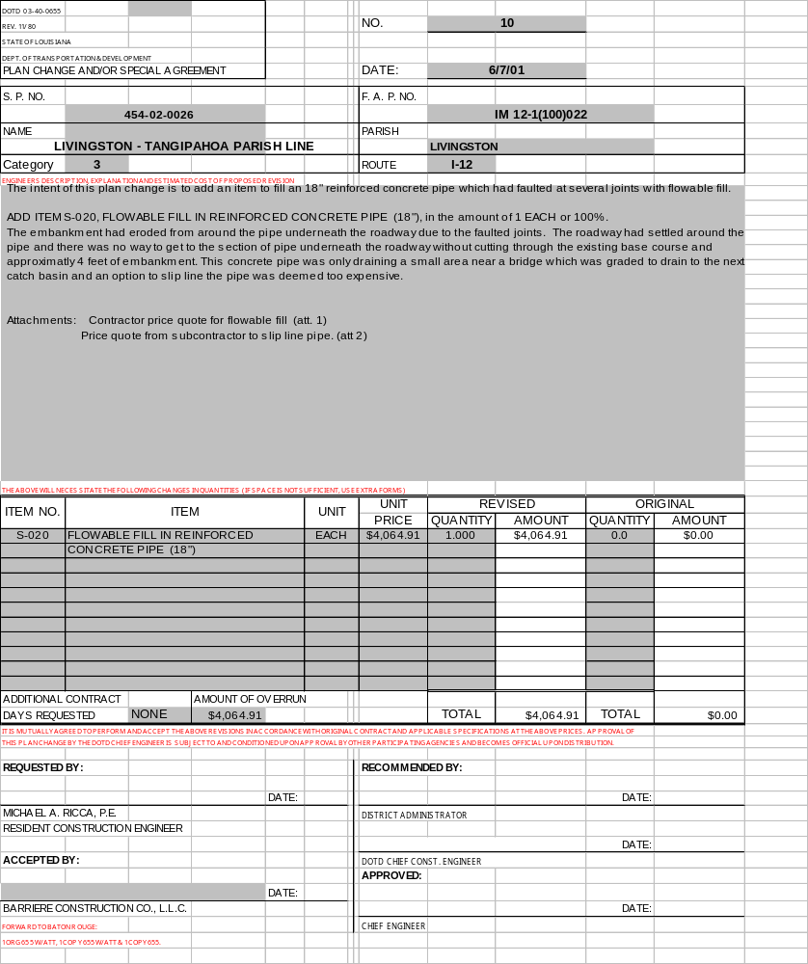
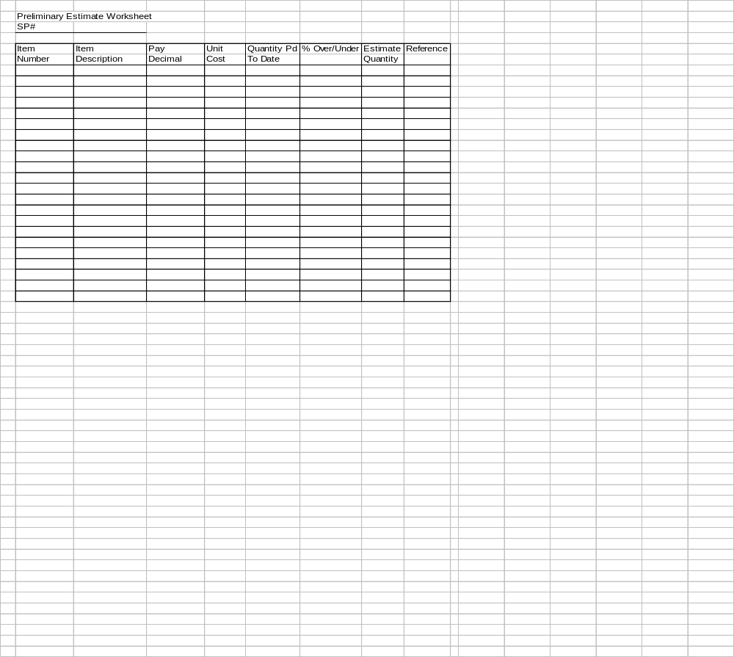
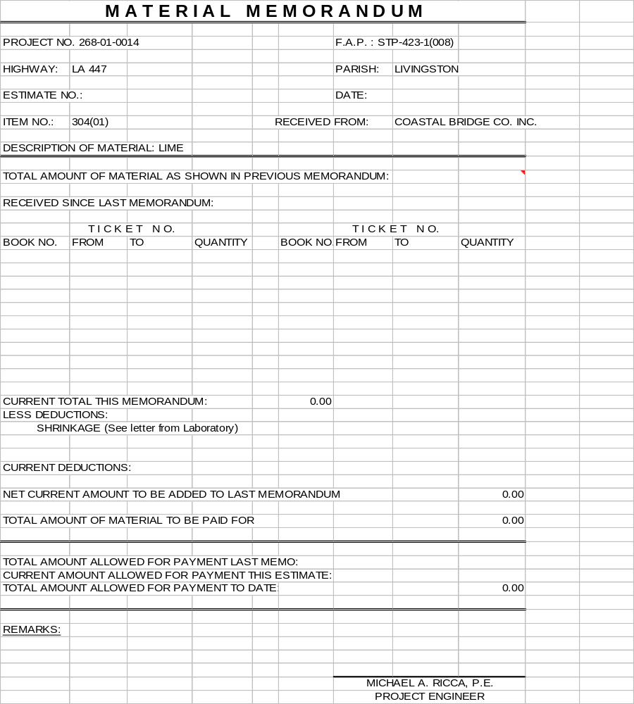
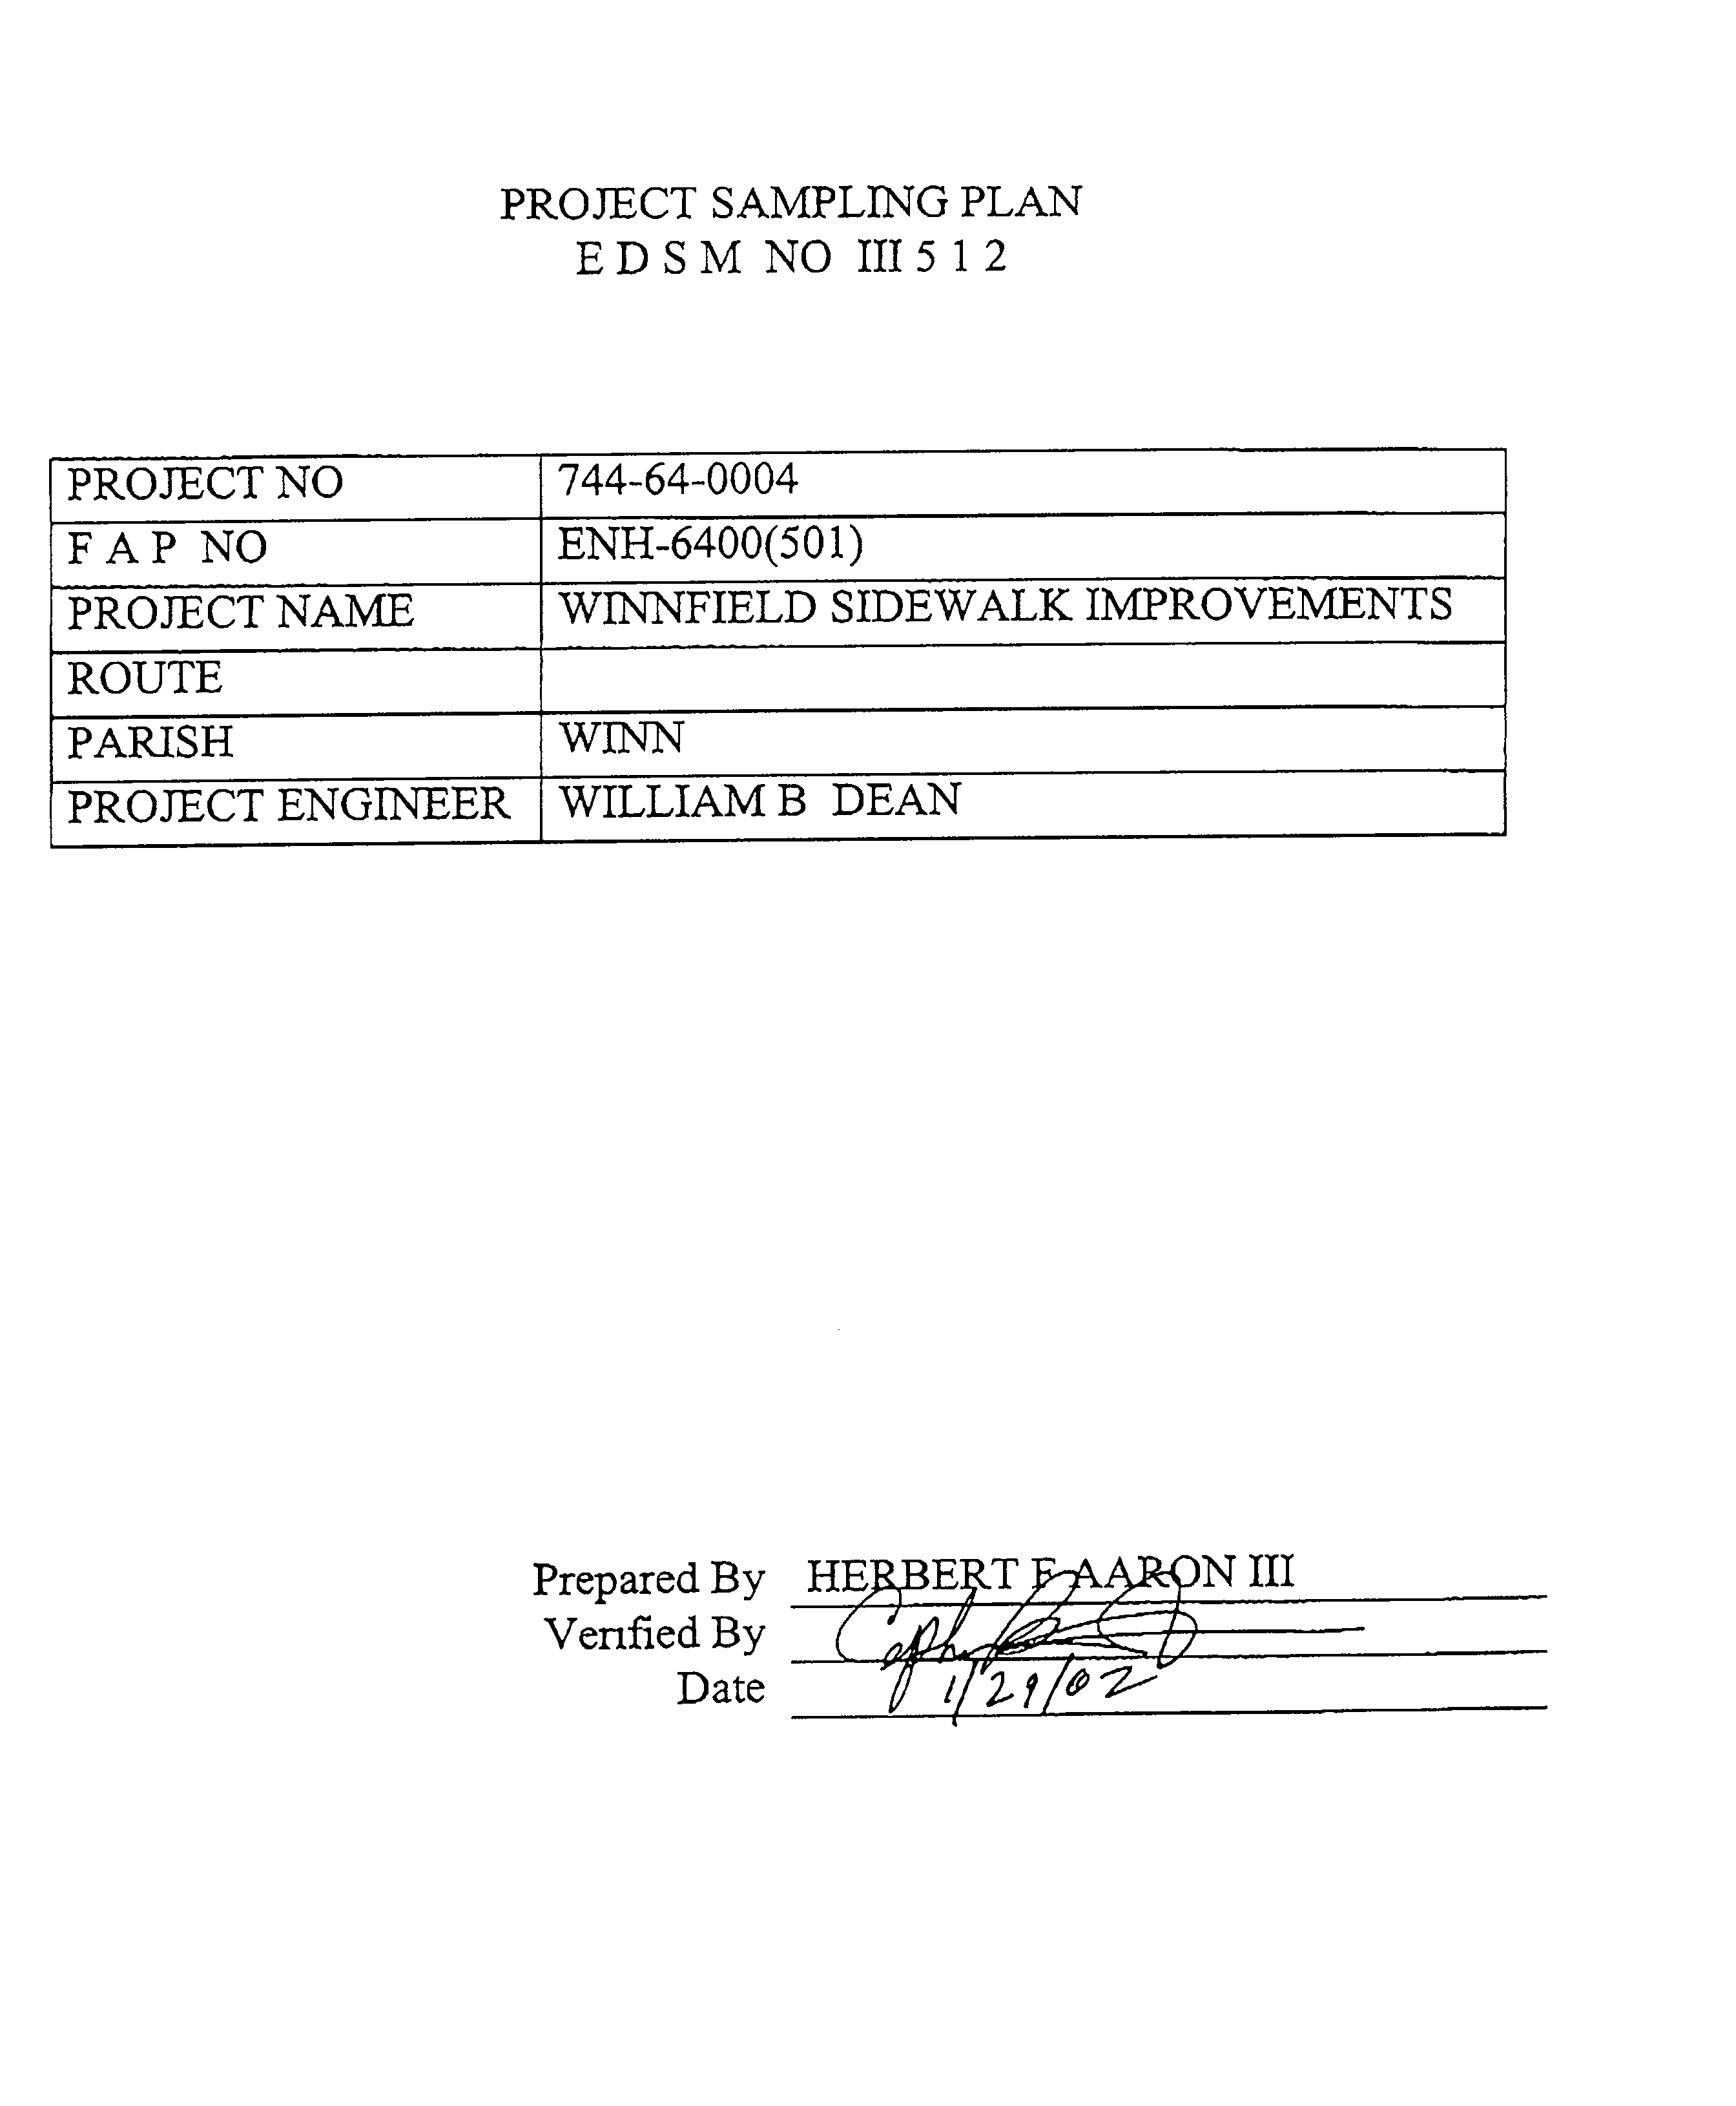
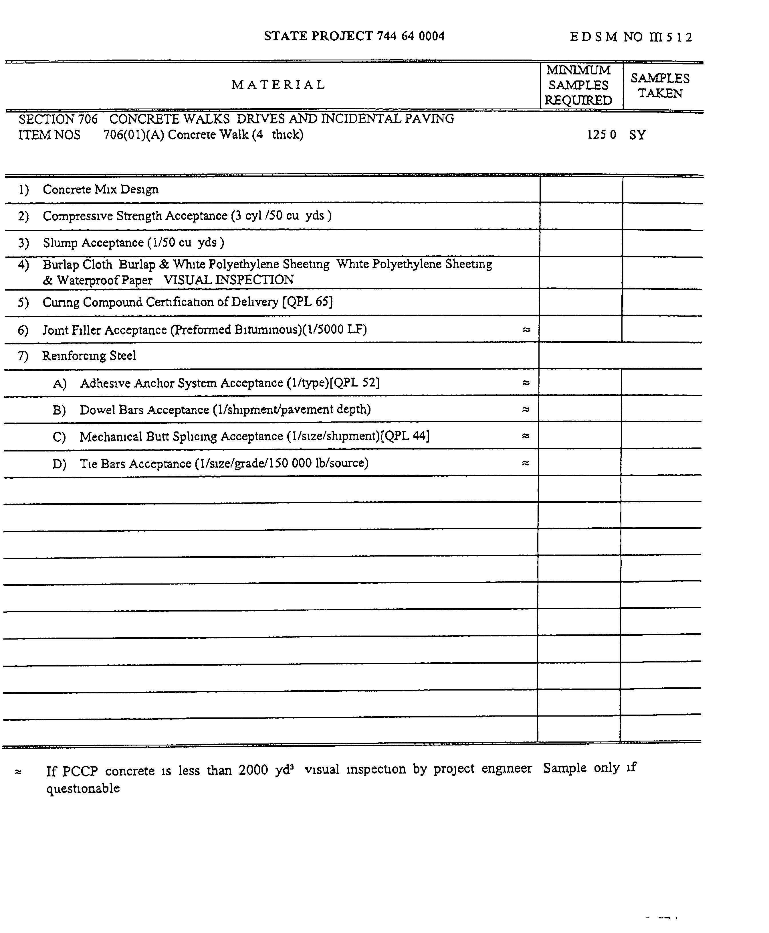
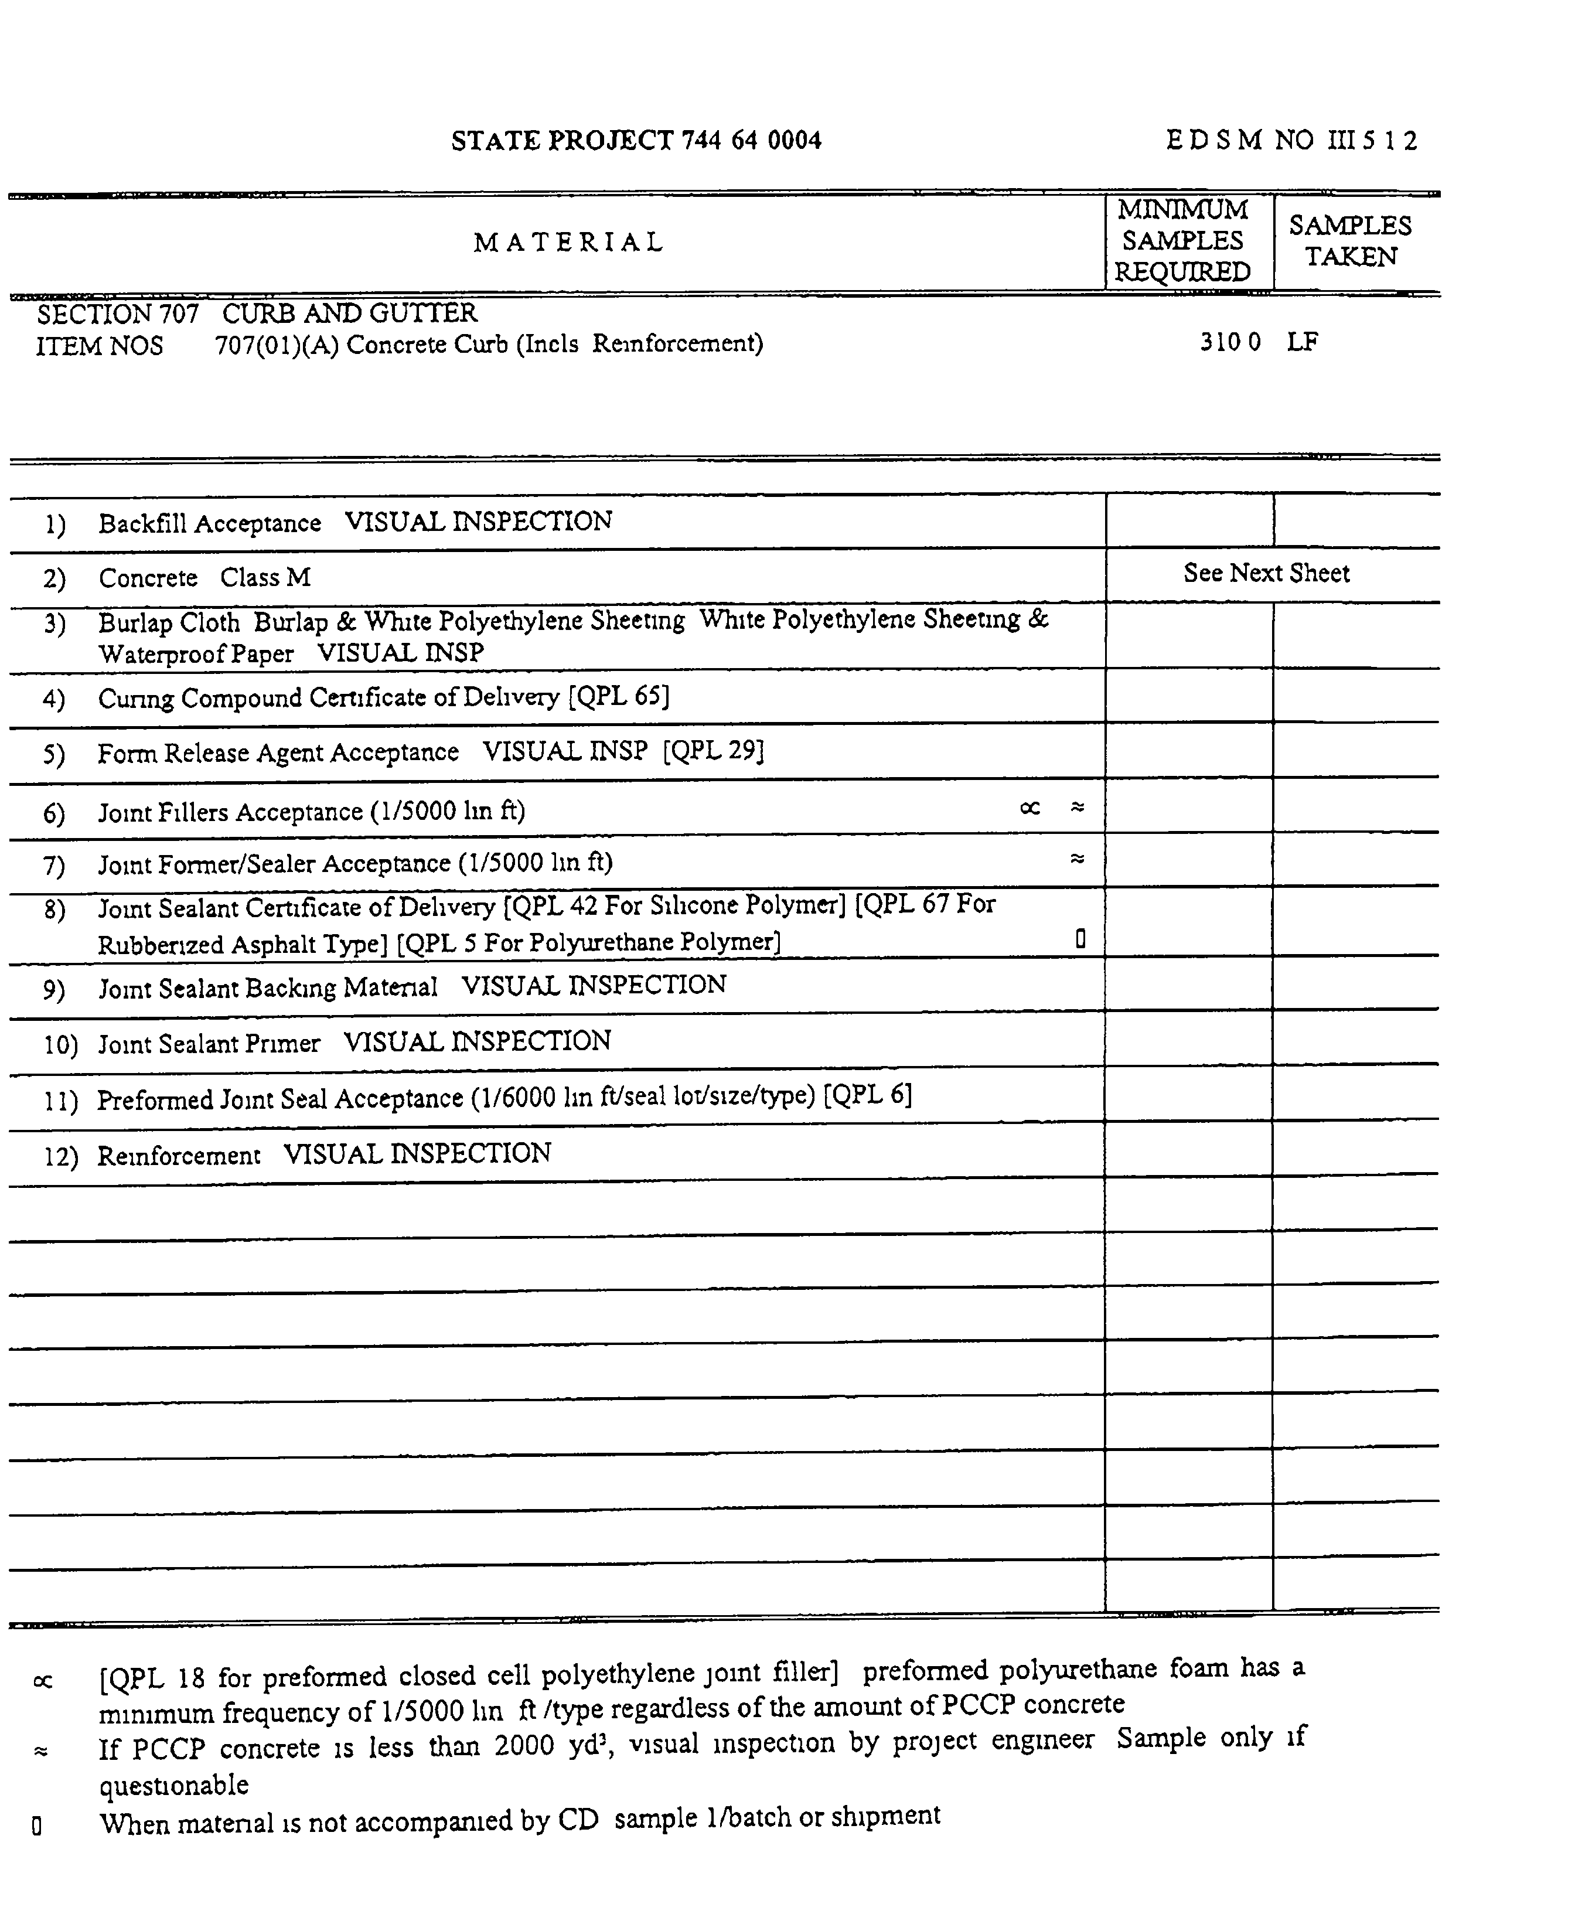
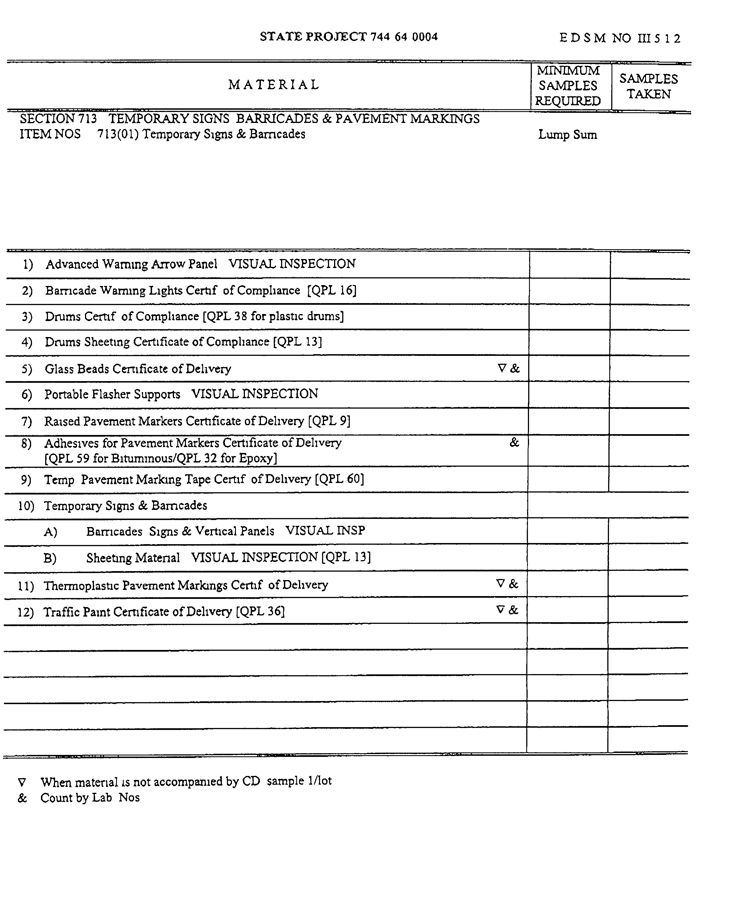
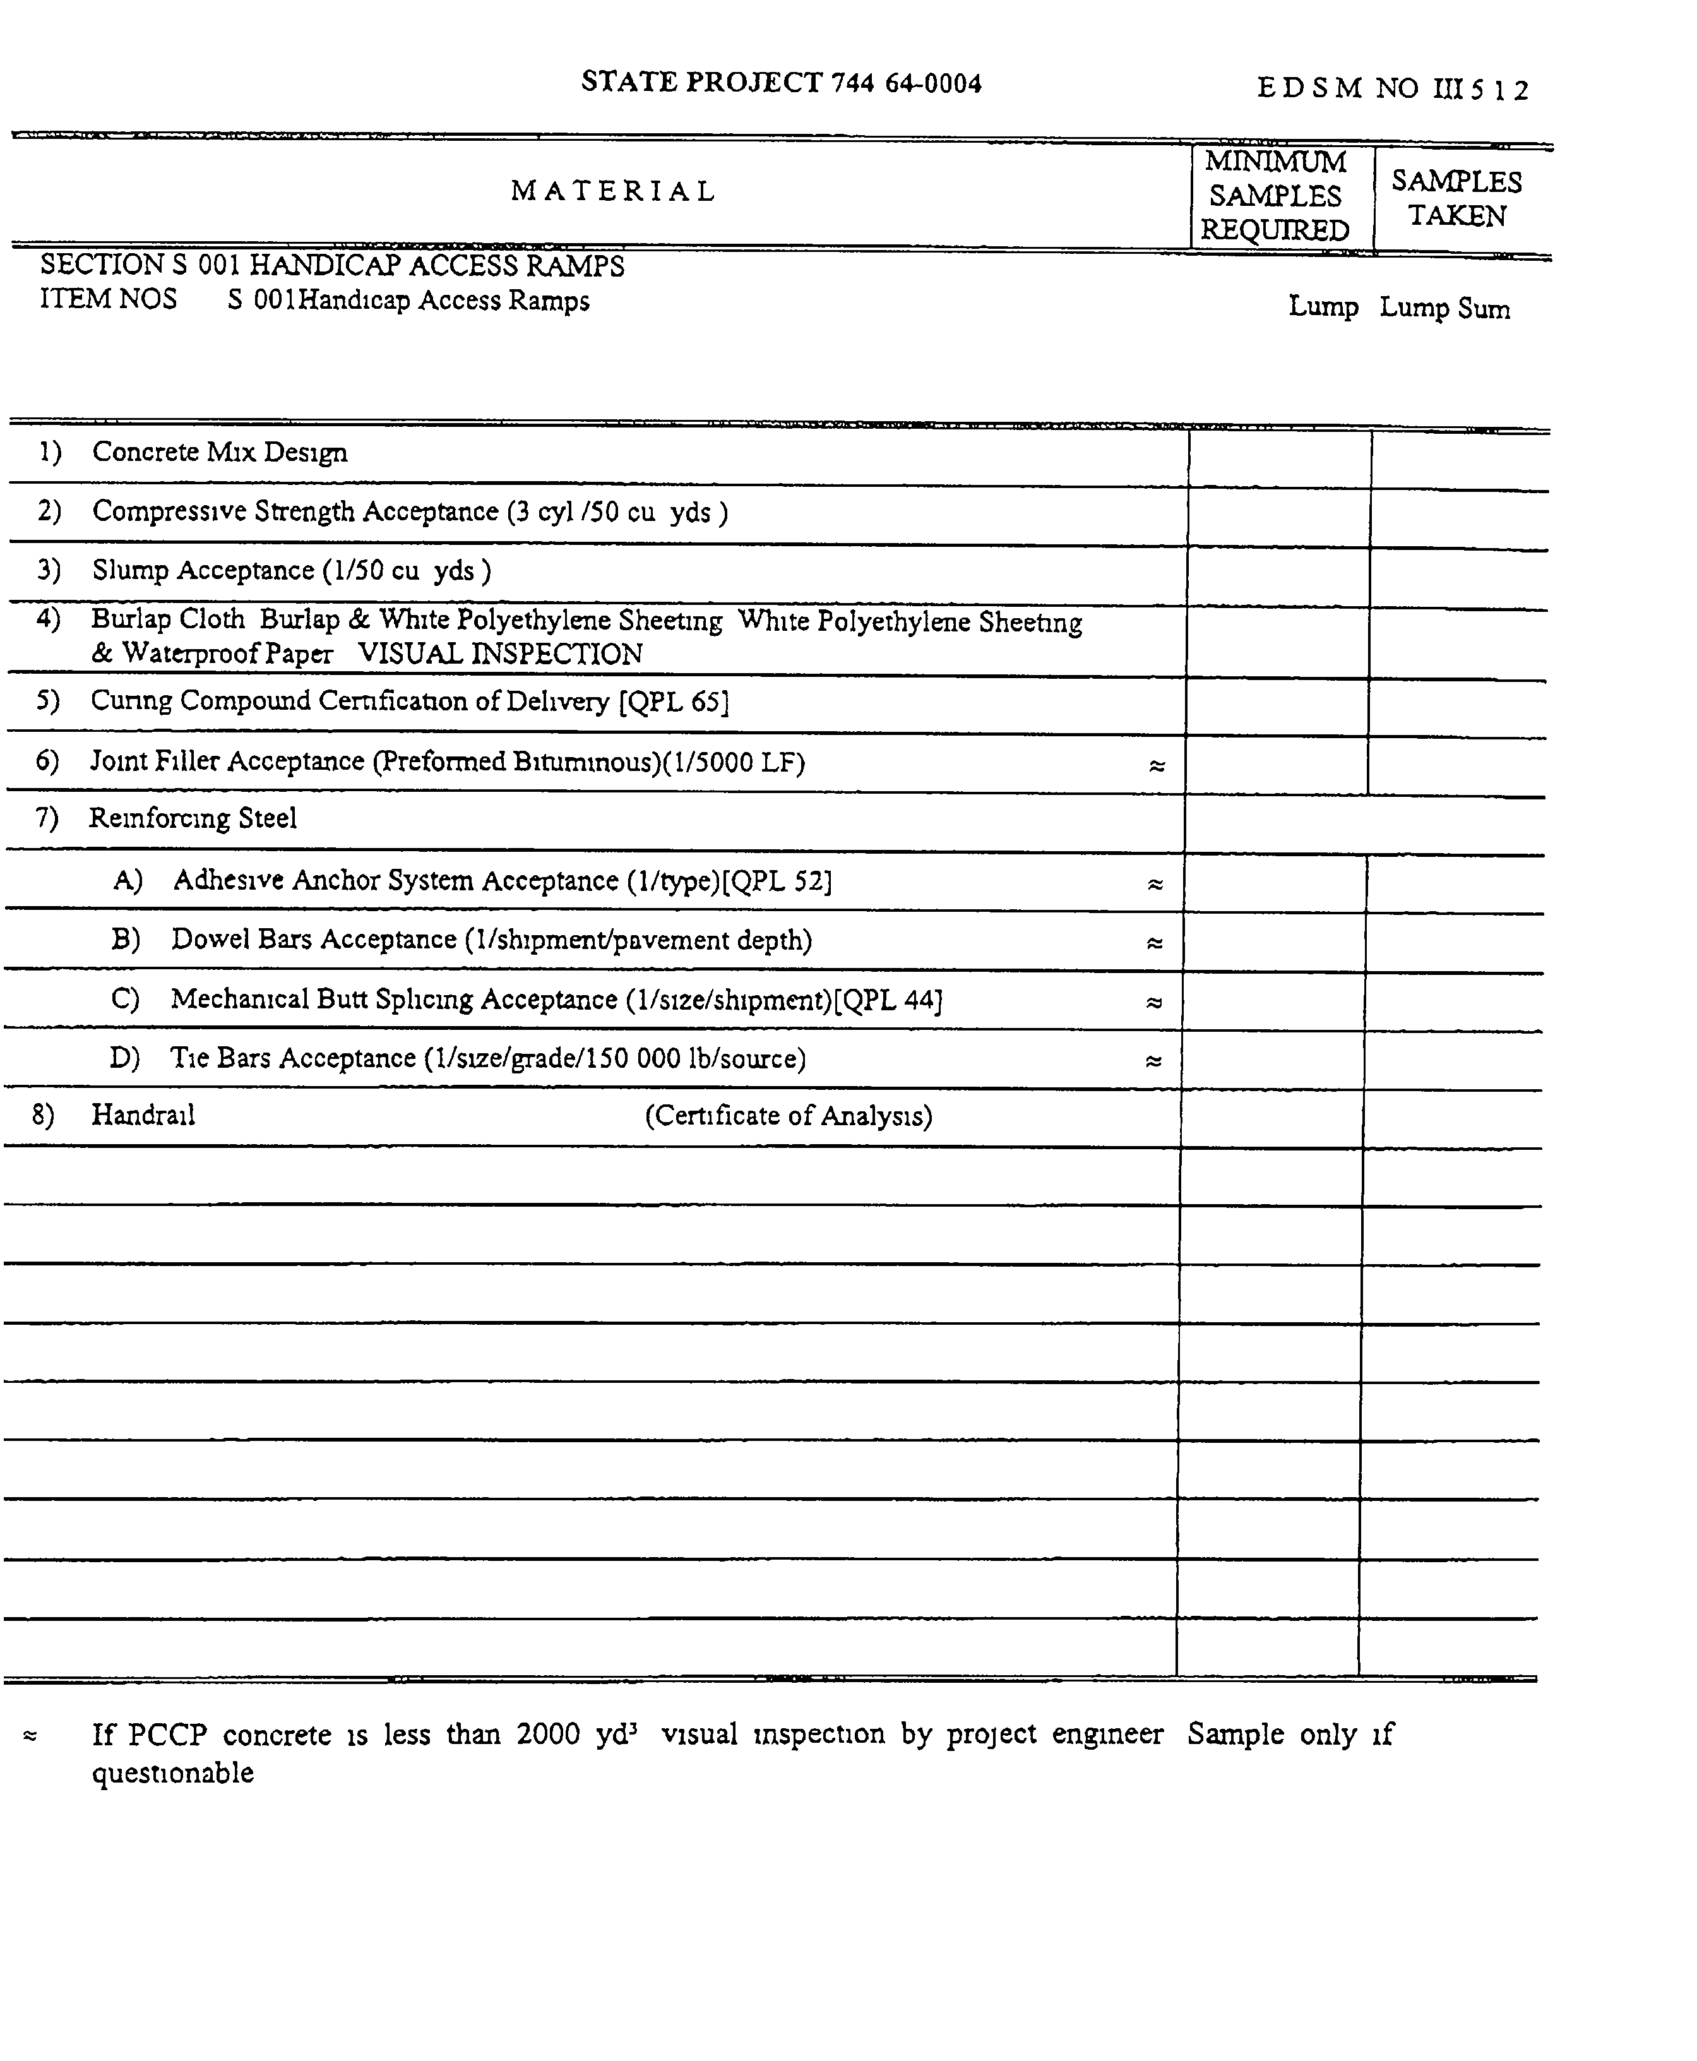
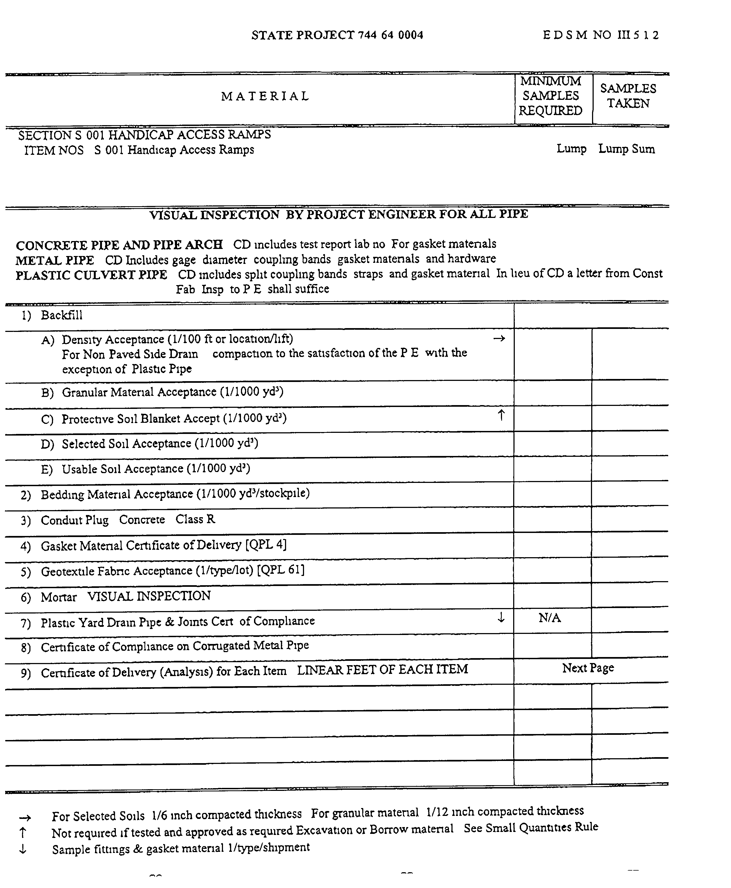
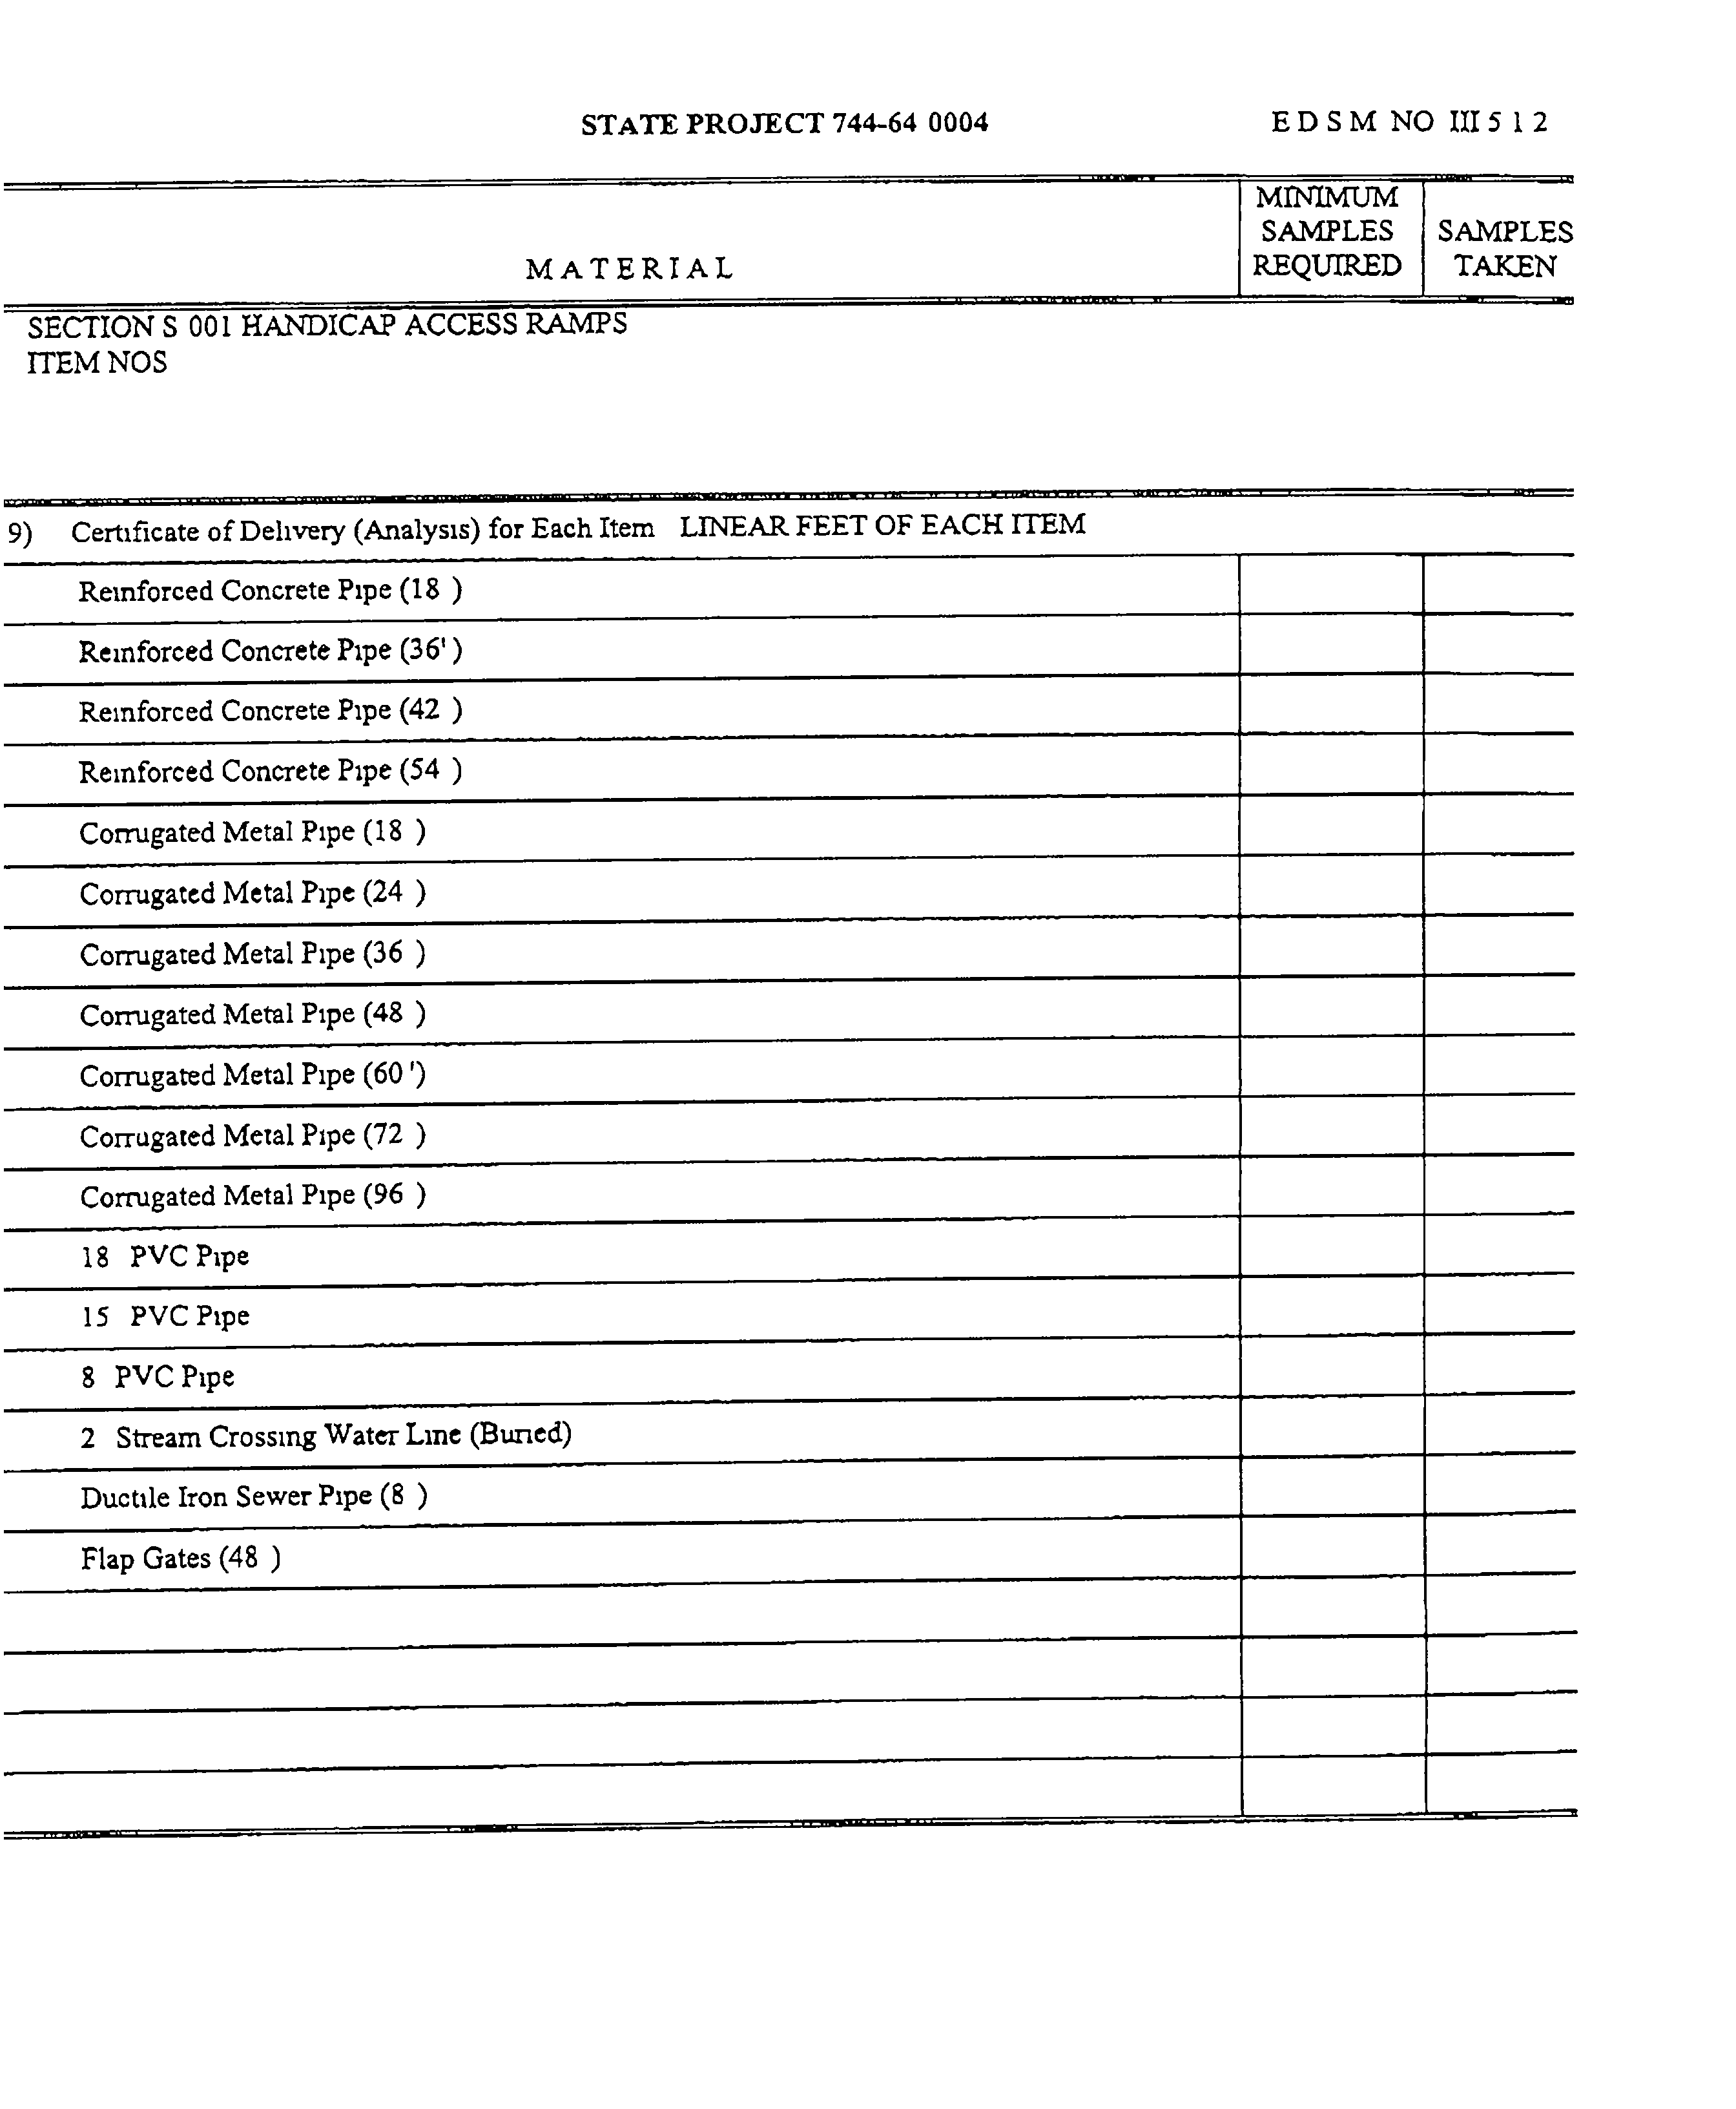
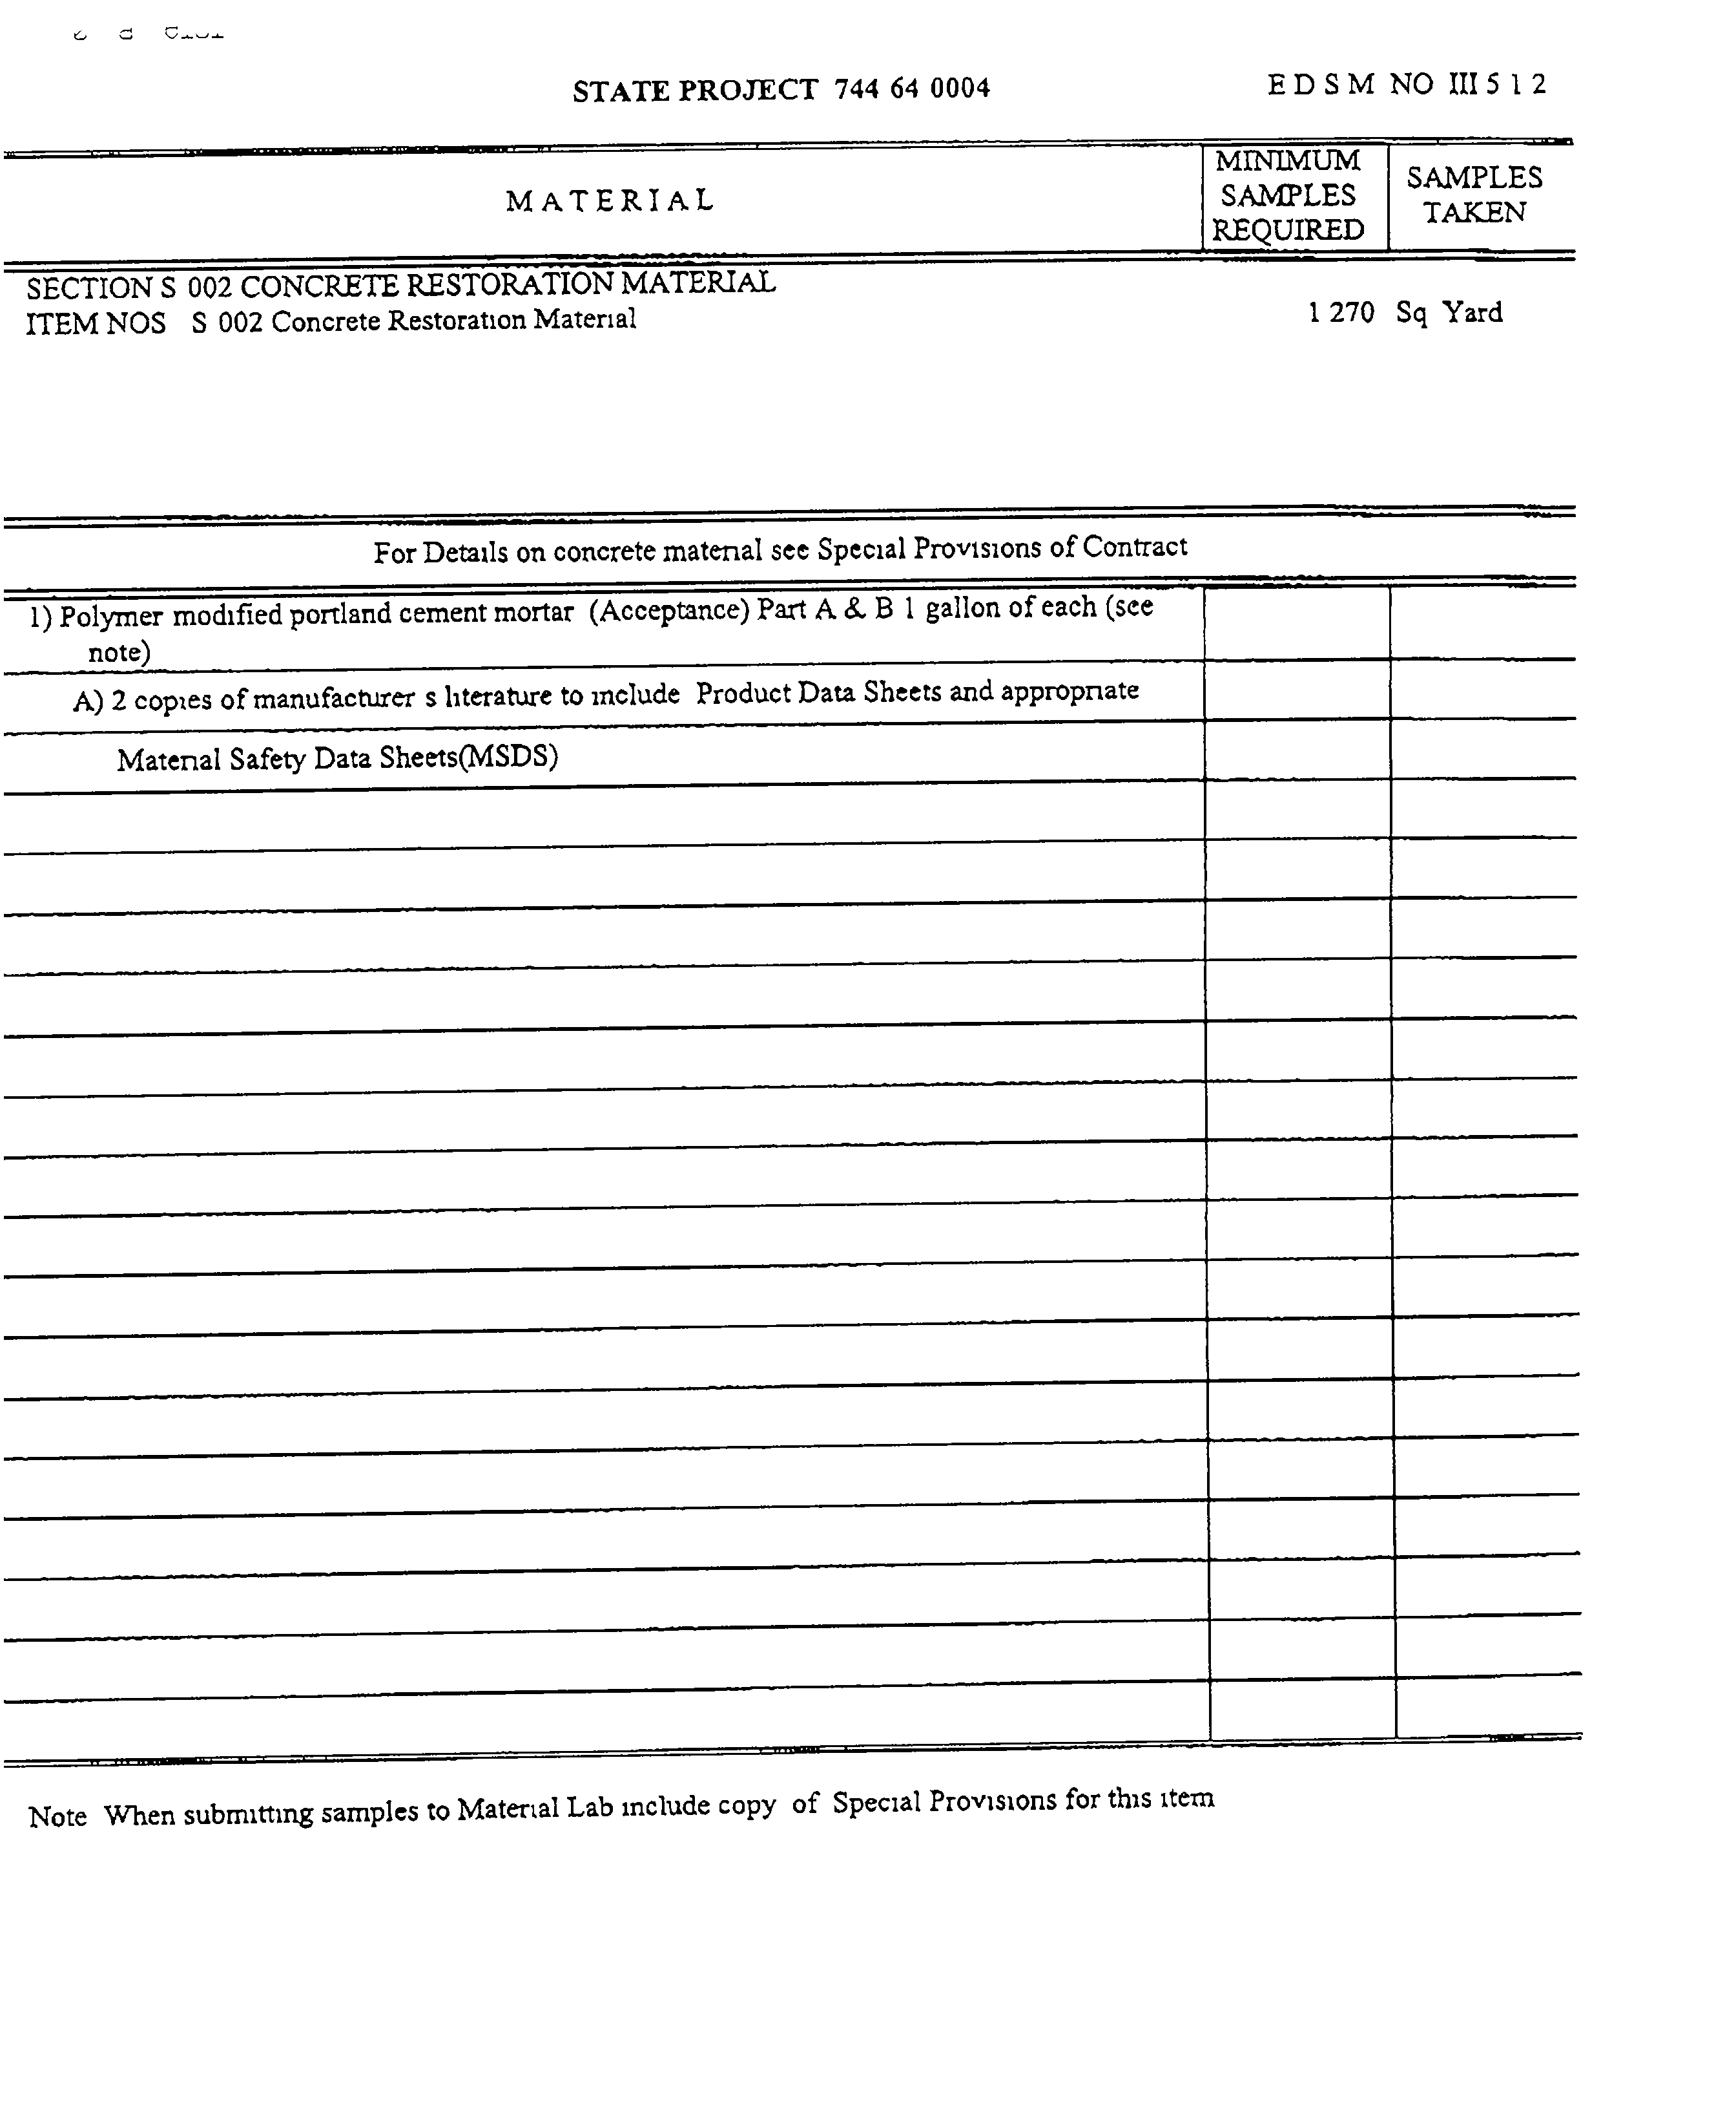

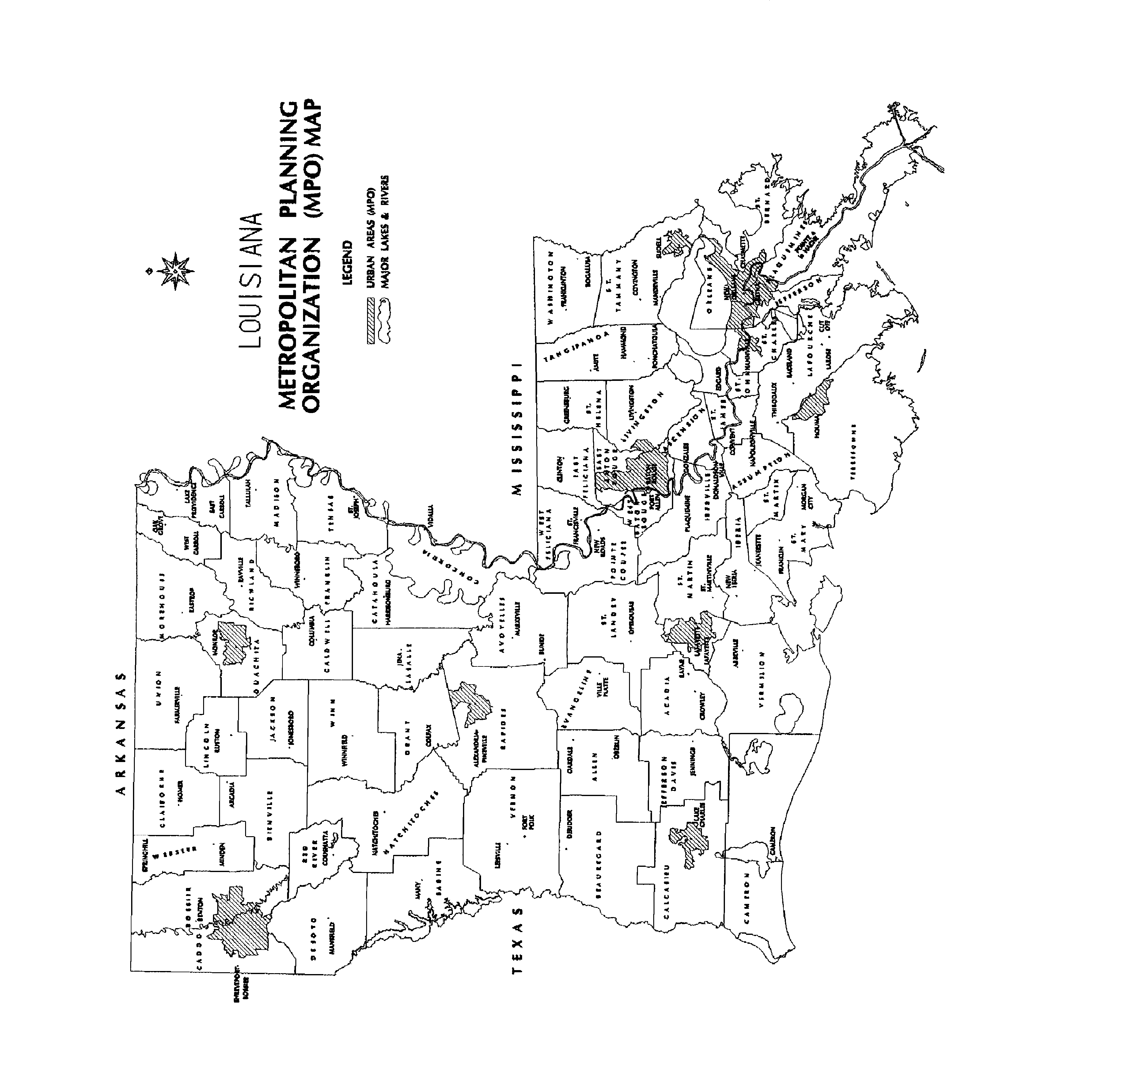

METROPOLITAN PLANNING ORGANIZATIONS

The following is a list of the metropolitan planning organizations for the state of Louisiana.

Alexandria-Pineville Area
Rapides Area Planning Commission
P.O. Box 7586
Alexandria, LA 71306
Contact Person: Matt Johns
Phone: (318) 487-5401, ext 11
Fax: (318) 487-5406
E-mail: matt@rapc.info

Baton Rouge/Baker/Brusly/Central/Denham Springs/Port Allen/Walker/Zachary Area
Capital Region Planning Commission
P.O. Box 3355
Baton Rouge, LA 70821-3355
Contact Person: R. J. Goebel
Phone: (225) 383-5203
Fax: (225) 383-3804
E-Mail: rgoebel@brgov.com

Houma Area

South Central Planning and Development Commission
Post Office Box 1870
Gray, LA 70359
Contact Person: Kevin Belanger
Phone: (985) 851-2900
Fax: (985) 851-4472
E-Mail: Kevin@scpdc.org

Lafayette Parish

Lafayette City-Parish Consolidated Government
Post Office Box 4017C
Lafayette, LA 70502
Contact Person: Mike Hollier
Phone: (337) 291-8016
Fax: (337) 291-8458

Lake Charles/Sulphur/Westlake Area

Imperial Calcasieu Regional Planning & Development Commission
P.O. Box 3164
Lake Charles, LA 70602
Contact Person: James Porter
Phone: (337) 433-1771
Fax: (337) 433-6077
E-Mail: james@imcal.org

Monroe/West Monroe Area

North Delta Regional Planning and Development District
1913 Stubbs Ave.
Monroe, LA 71201
Contact Person: Doug Mitchell
Phone: (318) 387-2572
Fax: (318) 387-9504
E-Mail: doug@northdelta.org

New Orleans Area/St. Charles Parish Urbanized Area/North Plaquemines Parish Area/ South St. Tammany Parish Area

Regional Planning Commission
10 Veterans Blvd
New Orleans, LA 70124
Contact Person: Walter Brooks
Phone: (504) 483-8500
Fax: (504) 483-8526
E-Mail: rpc@norpc.org

Shreveport/Bossier City Area
Northwest Louisiana Council of Governments
401 Market Street, Suite 460
Shreveport, LA 71101
Contact Person: Kent Rogers
Phone: (318) 841-5950
Fax: (318)-841-5952
E-Mail: nlcog@nlcog.org
CONTACTS

LA CRT Personnel

State Historic Preservation Officer

Ms. Pam Breaux

Louisiana Department of Culture, Recreation & Tourism
Division of Historic Preservation
PO Box 44247
Baton Rouge, LA 70804-4247
Phone Number: (225) 342-8200
Fax Number: (225) 219-9772
Website: www.crt.state.la.us

Louisiana Scenic Byways Manager

Mr. Doug Bourgeois

Louisiana Department of Culture, Recreation & Tourism
PO Box 44247
Baton Rouge, LA 70804-4247
Phone Number: (225) 342-8146
Fax Number: (225) 342-1051
E-mail: dbourgeois@crt.state.la.us

LA DOTD Personnel

Enhancement Program Manager

Valerie Horton

Louisiana Department of Transportation & Development
PO Box 94245
Baton Rouge, LA 70804-9245
Phone Number: 225) 379-1585
Fax Number: (225) 379-1351
E-mail: Val.Horton@la.gov

Enhancement Coordinator: Addresses are the same as the Enhancement Program Manager.

Steve Meek
Phone Number: (225) 379-1833
Fax Number: (225) 379-1351
E-mail: Steve.Meek@la.gov

Chief Landscape Architect

Roy Dupuy
Phone Number: (225) 379-1969
E-mail: Roy.Dupuy@la.gov

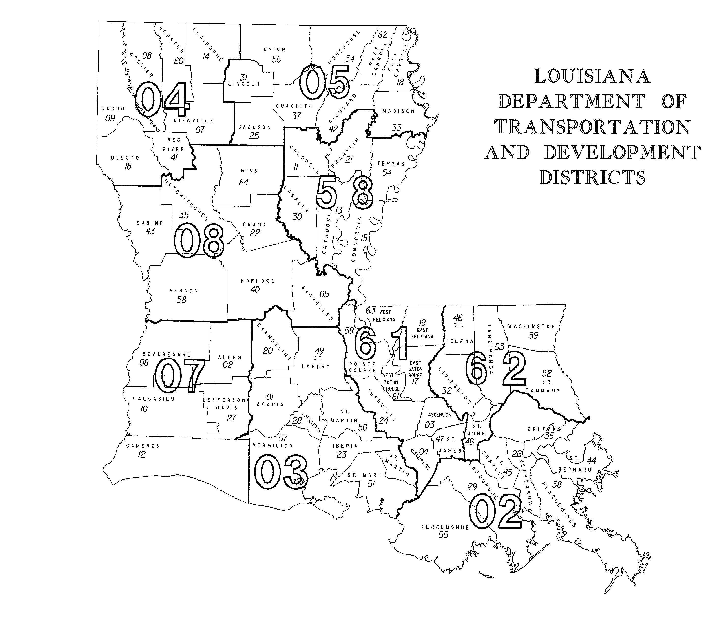

District Administrators

District 02 District 03

Michael Stack Vacant
PO Box 9180 PO Box 3648
Bridge City, LA 70096-9180 Lafayette, LA 70502
Phone Number: (504) 437-3102 Phone Number: (337) 262-6101
Fax Number: (504) 437-3260 Fax Number: (337) 262-6260

District 04 District 05

John Sanders Marshall Hill
PO Box 38 PO Box 4068
Shreveport, LA 71161-0038 Monroe, LA 71211
Phone Number: (318) 549-8301 Phone Number: (318) 342-0101
Fax Number: (318) 549-8463 Fax Number: (318) 342-0260

District 07 District 08

Steven Jiles Nick Verret, Jr.
PO Box 1430 PO Box 5945
Lake Charles, LA 70602 Alexandria, LA 71307-5945
Phone Number: (337) 437-9101 Phone Number: (318) 561-5101
Fax Number: (337) 437-9260 Fax Number: (318) 561-5288

District 58 District 61

Ricky Moon Roy Schmidt
PO Box 110 PO Box 831
Chase, LA 71324 Baton Rouge, LA 70821
Phone Number: (318) 412-3101 Phone Number: (225) 231-4101
Fax Number: (318) 435-3929 Fax Number: (225) 231-4108

District 62

Connie Standige
685 N. Morrison Blvd
Hammond, LA 70401
Phone Number: (985) 375-0101
Fax Number: (985) 375-0240

District Real Estate Managers

Region 1 Region 2
Districts 04 ,05 & 58 District 03, 07 & 08

Debbie Boutwell Robert Richard

La DOTD La DOTD
PO Box 4068 PO Box 3648
Monroe, LA 71211 Lafayette, LA 70502
Phone Number: (318) 342-0251 Phone Number: (337) 262-6250

Region 3

District 02, 61 & 62

Hubert Graves (Acting)

La DOTD
PO Box 94245
1201 Capitol Access RD – EW RM S-330
Baton Rouge, LA 70804-9245
Phone Number: (225) 242-4537

