How to Publish PDFs for Louisiana DOTD in ProjectWise Explorer
Louisiana DOTD has changed the way it supports publishing DGNs to PDF.

Publish to PDF for Consultants tool no longer supported
As of June 1, 2023, the Publish to PDF tool formerly provided by Louisiana DOTD to employees and consultants for ProjectWise Explorer V8i is no longer used or supported. While the command may even appear to operate normally if you still have it, the PDFs will not publish. Do not use it.

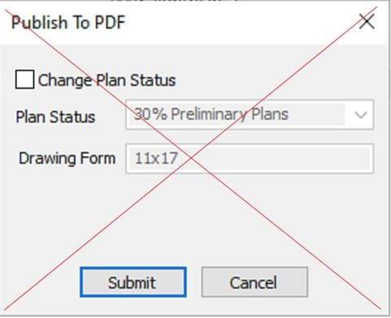

If you have previously installed the "ProjectWise PDF Extension for LADOTD Consultants" (or similarly named package), please uninstall it via your Windows Control Panel. Once it is removed, you will no longer see a Publish to PDF command in ProjectWise Explorer menus.

Create Renditions: the new way to publish PDFs for LaDOTD
Louisiana DOTD now supports PDF publishing within ProjectWise Explorer via the Create Renditions command. This command is available in the Document menu and Folder menu. It is native to ProjectWise Explorer so no additional software or configuration is needed to use it.

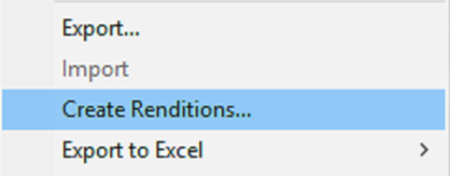

Publish single page PDFs
To publish single page per file PDFs, select one or more DGN files in ProjectWise Explorer, and then select the Create Renditions… command from the Document menu (either by selecting Document from the menu bar, or right-clicking on selection, the latter is shown below). Alternatively, to publish all DGNs in a selected folder, you can right-click on it (or select Folder from the menu bar), then click on Create Renditions… command in the menu.
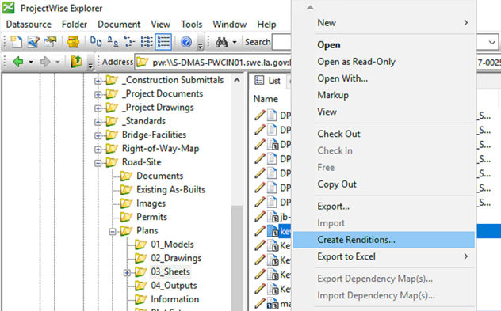

A Create Renditions dialog appears. If you have used Publish to PDF, then some of the choices may look familiar; Profile is equivalent to Plan Status, and Presentation is equivalent to Drawing Form. Select a Profile option first, then select an available Presentation option: 11x17 (default), full size, or letter.

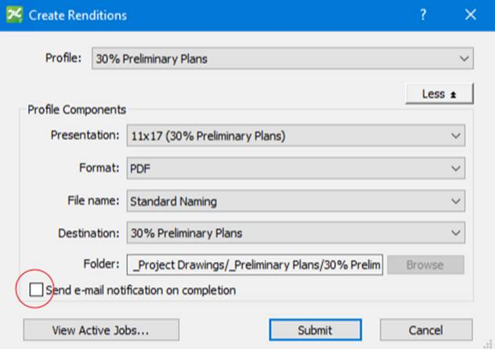

NOTE: When changing the selected Profile, any change made to Presentation will be reset to the default.

The Profile Components for Format and File Name only offer one choice and are always the same. Destination and Folder options are controlled by the Profile selected and are not changeable. The dialog will always default to Send email notification on completion, but it can be turned off as needed. PDF output is saved in the Folder path shown (relative to the parent Work Area)

NOTE: if fewer Profile Components are showing in your Create Renditions dialog, there will be a More button where the Less button is – click it to show all Profile Components. The View Active Jobs… button only appears in newer versions of ProjectWise Explorer Connect Edition.
TIP: click the View Active Jobs… button before clicking Submit to open the iCS for PDF Active Jobs dialog and monitor progress of your job, which will show in list shortly after clicking Submit.

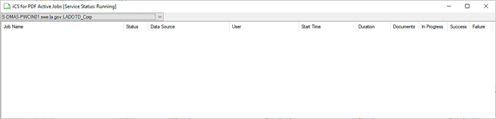

NOTE: the dialog may disappear behind the active ProjectWise Explorer window when it loses focus, but is still open.

Publish multi-page PDFs
Publishing multi-page PDFs is now supported by the Create Renditions command, but it only works on flat sets in ProjectWise Explorer Connect Edition. Flat sets renditioned from ProjectWise Explorer V8i SS4 still only output single page PDFs for each DGN in the set.

If the flat set doesn't already exist, create it by selecting all the DGN files to be published in the PDF, then right-click (or select Document from the menu bar) and select Set, then New...

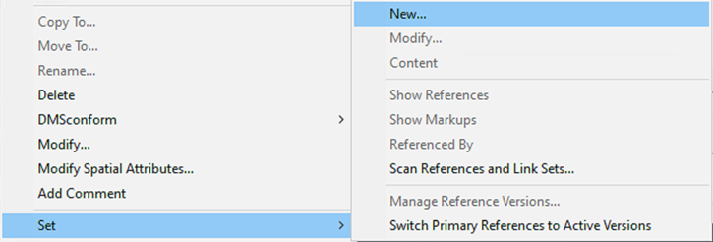

In the Create Document Set dialog, give the Document Set an appropriate name and then click OK.

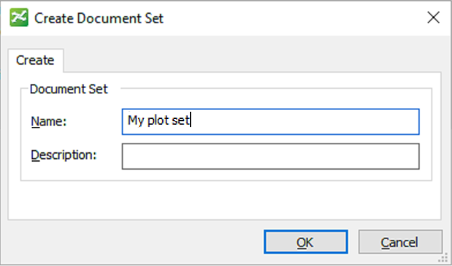
A dialog showing the contents of the flat set will appear. It is ok to close it.

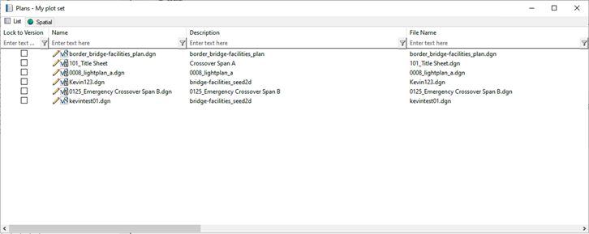

The newly created set will appear in the Document list of the folder where you created it.

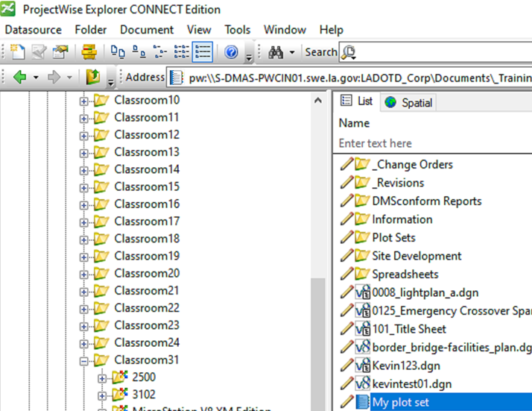

To create a multi-page PDF of all the DGNs in the set, right-click on the set (or select Document from the menu bar) and select Create Renditions... Then follow the same directions for the Create Renditions dialog as shown in the "Publish single page PDFs" section of this document.

